

Mathematics

This term we will be deepening our understanding of the place value system and addition and subtraction.

Recognise the place value of each digit in a three-digit number

Compare and order numbers up to 1000

Read and write numbers up to 1000 in numerals and words

Identify, represent and estimate numbers using different representations

Add and subtract numbers mentally

Add and subtract numbers with up to 3 digits using formal written methods (column)

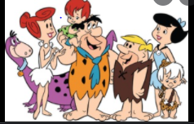

**French**

In French this term we will be learning about the basics of the French language including phonics and initial conversation starters.

**PSHE**

The theme this term is Being Me in My World. We will be learning to recognise how our behaviour can affect how others feel and behave as well as understanding why it is important to have rules and how that helps us and others learn. We will learn to explain why it is important to feel valued.

**P.E**

In PE this term we will be focusing on personal skills such as persevering and challenging ourselves to improve our performance. We will also be focusing on coordination skills and static balances.

**History**

We will immerse ourselves in the period of history from the Stone Age through to the Iron Age. We will be exploring what life was like for people and how they survived. We will also be discovering more about Stone Henge and Skara Brae.

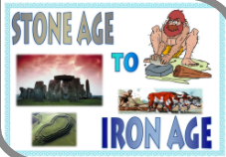

**Art**

In Art this term we will be looking at paintings by Vincent Van Gogh and using these as inspiration to develop our skills in brush strokes, creating tone and experimenting with different types of paint.

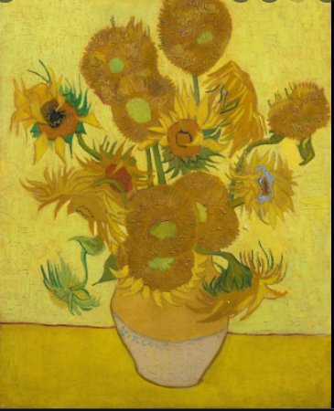

**English**

This term our English will centre around the texts How to Wash a Woolly Mammoth and Stone Age Boy. We will be focusing on writing a set of instructions and writing a story using our ‘Stone Age Boy’ text as a stimulus. We will also be learning lots of new spelling, grammar and punctuation to use in our own work.

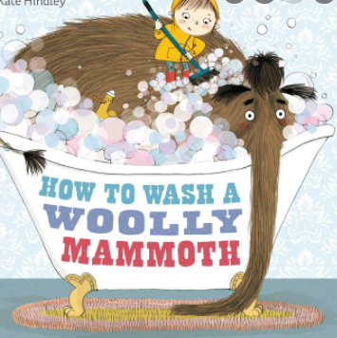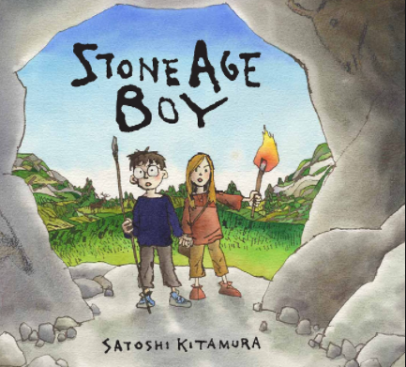

**Music**

We will be learning the song ‘Let your spirit fly’ by Joanna Mangona and learn about pulse and rhythm. We will learn to sing and play along with instruments.

**I.C.T**

Children will develop their understanding of digital devices, with a focus on inputs, processes and outputs. We will look at computer networks that include network infrastructure devices like routers and switches.