**PSHE:**

We will be looking at ‘Being me in my world.’ We will be learning about rules and rewards and feeling proud.

**Maths:**

This term we will be learning about place value (to 10) and addition and subtraction. (to 10)

**English:**

In English we will be reading – Amelia Earhart (Little People, Big Dreams),

We will be writing letters and journals and making sure we are using capital letters, full stops and finger spaces in our writing.

**Music:**

This term we will be learning the song ‘Hey You’ and listening to and appraising different music.

**Geography:**

We will be learning about the seasons and weather, comparing countries Antarctica and Africa and learning about the different clothes we would need to wear in different countries.

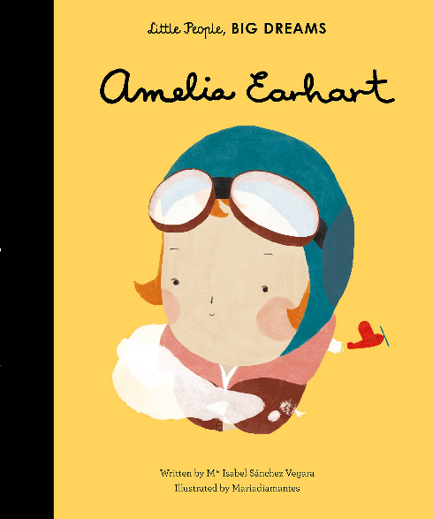Term 1 - Travel

**PE:**

This term we will be practicing our co-ordination skills, practicing balancing and learning different footwork skills.

**R.E:**

This term we are looking at Christianity and talking about ‘Does God want us to look after the world?

**Computing:**

This term we will be learning about the technology in our classroom and around us.

We will also be learning how to use a computer sensibly.

**Art/DT:**

This term we will be learning about painting. We will be looking at primary and secondary colours, brushstrokes and making a class collage.

**History:**

We will be learning about the history and timeline of planes, Amelia Earhart and looking at the first plane flight.

We will also be making comparisons between travel from the past and now.

**Science:**

Our science topic this term is ‘Celebrations.’ We will be learning about darkness and light, identifying and classifying materials and looking at plants.