The Mysterious Mayans Homework!
Pick at least 3 of these projects, linked to our Geography Topic, to complete and earn a house point. Bring your projects in by Thursday 26th May
Write a message using the Mayan Hieroglyphs.  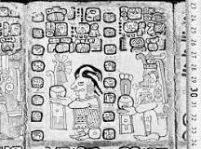 | 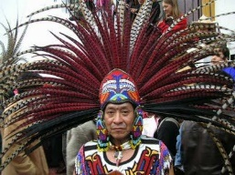  Can you design and create your own Mayan headdress? Write a paragraph about why they wore them. | Can you research a Mayan city? What can you find out about it? What was it like? Write a fact file about it!  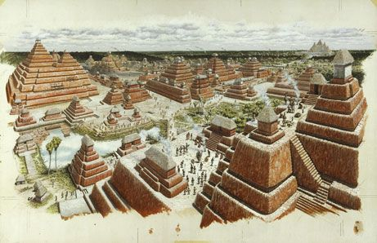 | Can you draw or make a Mayan temple? Write about why the temples were so important to the Mayans.  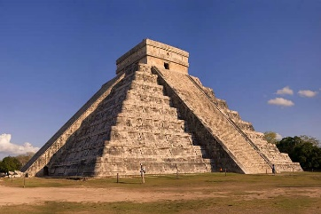
What Mayan myths can you find out about? Re tell the story in your own words!  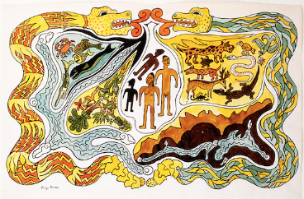 | Can you write your own Mayan myth? What kind of characters will you include? Write or type your myth!  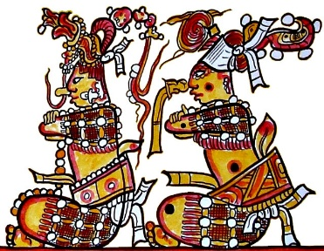 | What were the Mayan warriors like? Can you draw a picture of one? Write about who they were and what weapons they had.  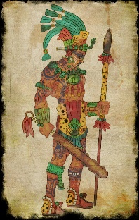 | Where about in the world did the Mayan’s live? Use a map to find out! Can you plot the different Mayan cities on the map?  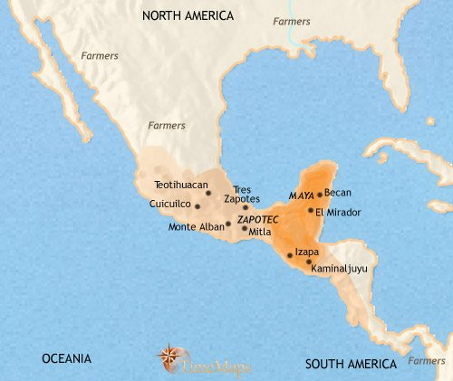
The Mayan’s loved chocolate. Can you find out about how chocolate is made? Draw a flow chart to show the process of making chocolate. You could use pictures and diagrams to help.  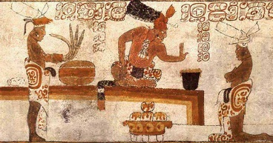 | Think about your favourite chocolate treat? Design a wrapper for a new chocolate bar you have invented.  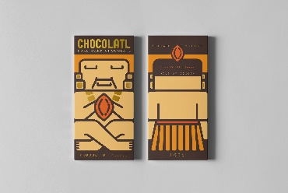 | The Mayans were great farmers and enjoyed eating tortillas filled with cooked vegetables! Can you design your own Mayan tortilla recipe? Perhaps you could even make it!  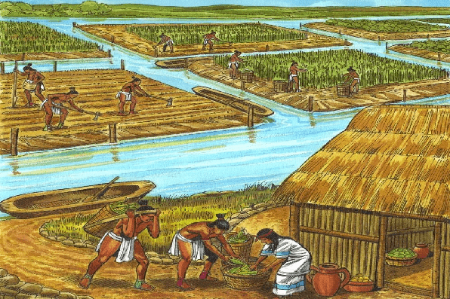 | Can you find out about the different Mayan gods? Can you draw a picture of what you think they looked like? Write about what you have found out.  