Invent a new Olympic sport. It can be a mixture of others or completely new. Write some instructions for how to play it.  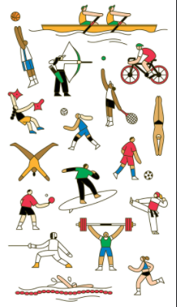 | Design and label an Olympic stadium for the future host countries of the Olympics.  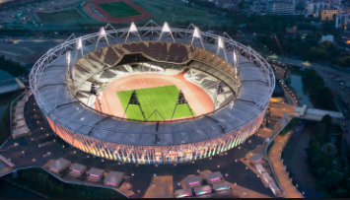 | Write a poem about an Olympic sport(s) of your choice.  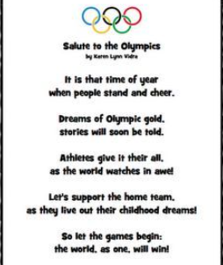 | Write a story about an athlete competing in the Olympics.  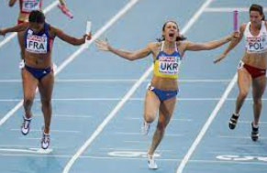
Research and produce an information poster about a famous Olympic athlete. They can be from any country. | Design and make an Olympic torch from materials of your choice.  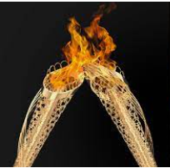 | Create a table of similarities and differences between the ancient Olympics and modern Olympics.  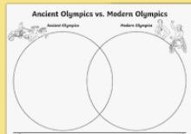 | Create an information poster about the Paralympics. When did they begin and what do they involve?  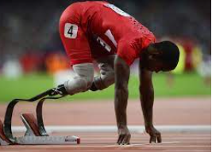
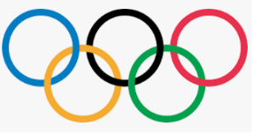
Term 6: Homework Grid- Olympics 2021

