**In English we will writing in a range of different styles including riddles, character descriptions, setting descriptions, stories and reports.**

We will be continuing to develop our understanding of technical terms including noun, verb, adverb and adjective, apostrophe, comma, connectives, exclamations and questions.

We should still be joining the letters in our writing.

**In Geography** we will be checking our knowledge of the names and locations of the continents and oceans of the world.

We will also be learning about compass directions and using these to read and create our own maps.

Year 2

Pirates /

Under the Sea

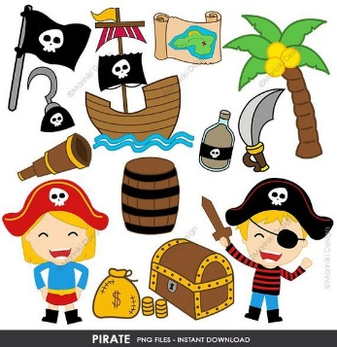

**In DT** we will be planning, making, testing and evaluating our own floating boats.

**In History** we will be learning things from the past and how they compare with things in the present.

We will learn about beaches from the Victorian time and comparing how life is different now.

**Thank you to all who regularly engage with home learning and dojo.**

**In Maths, we will be learning about:**

**Time:**

- Compare and sequence intervals of time.

- Tell and write the time to five minutes, including quarter past/to the hour and draw the hands on a clock face to show these times.

- Know the number of minutes in an hour and the number of hours in a day.

**Length and Height:**

- Choose and use appropriate standard units to estimate and measure length/height in any direction (m/cm) using rulers.

- Compare and order lengths and record the results using >, < and =

**Geometry (direction and position):**

- Use mathematical vocabulary to describe position, direction and movement, including movement in a straight line and distinguishing between rotation as a turn and in terms of right angles for quarter, half and three-quarter turns (clockwise and anticlockwise).

**In Art** we will be creating our own tea-stained pirate maps.

**While reading with your child please continue to focus on comprehension and widening our vocabulary.**

We should be reading most words from sight, only needing to sound out strange new words. This will mean the speed of our reading increases. In Year 2, we should be reading **90 words a minute.**

Reading fluently allows us to focus on understanding what we have read. You can continue to practice recalling facts from your reading, answering “why” questions and ordering statements about a text.

**In Science we will be learning more about animals and their habitats.**

* Identify that most living things live in habitats to which they are suited and describe how different habitats provide for the basic needs of different kinds of animals and plants.
* Identify and name a variety of plants and animals in their habitats, including microhabitats
* Describe how animals obtain their food from plants and other animals, using the idea of a simple food chain, and identify and name different sources of food.