Term 5- Kingfishers Homework Grid. Romans
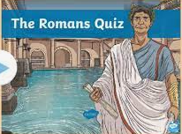  Create a quiz with facts about The Romans. Make sure you also have the answers! | Write a secret message using Roman numerals.  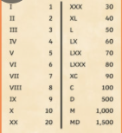 | 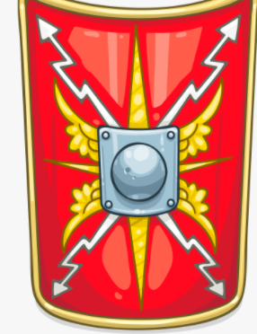  Design and create your own Roman shield. | 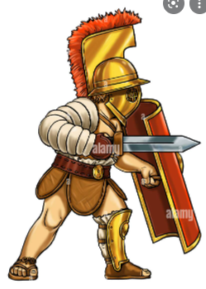  Draw a Roman gladiator.
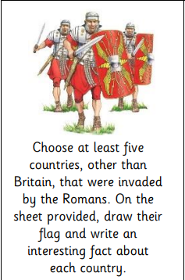 | 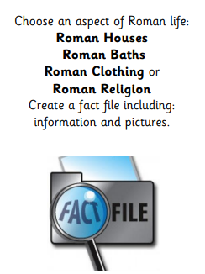 | Create a fact file about a Roman invention. | Write a story about life during the Roman period.  