Term 4- Kingfishers Homework Grid.
Food Glorious Food!
Create a poster about where our food comes from.  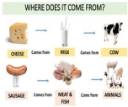 | 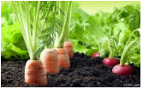  Use the internet and/or books to find out about different foods that grow in different places around the world or just in the UK. | 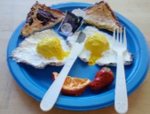  Make a representation of your favourite meals. You can use a variety of materials you may have at home e.g. string for spaghetti. | Make a collage of food packaging that you have eaten over the next few weeks.  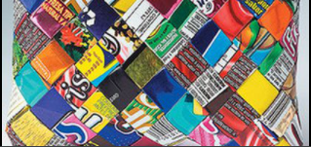
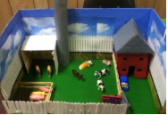  Use materials from around the home e.g. shoe boxes, paper and paint, milk bottles etc to create a scene of where food comes from (e.g. fishing, farm, factory) | Create a poster about why it is important to eat a healthy and balanced diet. Use internet/ books to help you.  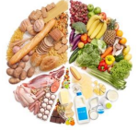 | 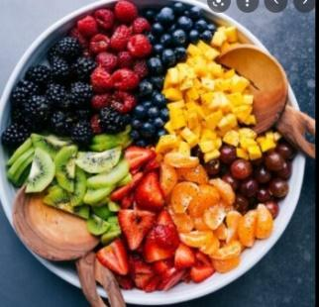  Make a fruit salad and find out where each piece of fruit has come from. Take photos of you enjoying it! | 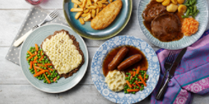  Help prepare a dinner with an adult’s help and try to use farm produce. Write down the recipe and ingredients used and of course take photos of your meal.  