- Write an acrostic poem about the Stone Age.  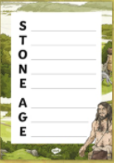 | - Create a Stone Age diorama.  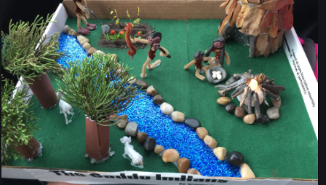 | - Paint a stone with an image of a Stone Age animal, symbol or human.  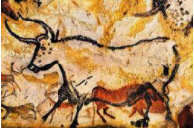 | - Make a quiz with facts about the Stone Age. Make sure you also have the answers.  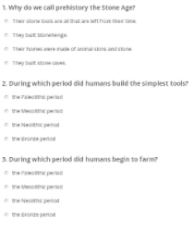
- Draw and list animals that existed during the Stone Age.  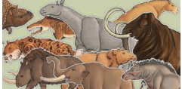 | 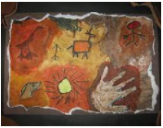  - We know that the first recordings of art were cave art. Using materials of your choice, create your own cave painting. | - Design and make a Stone Age hunter’s spear.  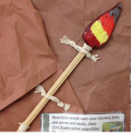 | 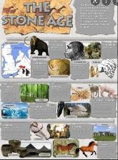  - Create an information poster about the Stone Age. Make it bright and colourful.

