Safe
SEVEN FIELDS PRIMARY SAFEGUARDING AND CHILD PROTECTION POLICY
September 2020

Safeguarding and Child Protection Policy and Procedures
Seven Fields Primary School

Page number | Title
2 | Quick Reference Contacts Guide
Part 1 - Procedures
4 | Worried About A Pupil
6 | The Role of The Designated Safeguarding Lead and Deputy DSL/s In Our School
8 | Early Help
10 | Making A Referral to Social Care
10 | Escalation
11 | Worried About the Actions of An Adult Who Works/Volunteers with Pupils
Specific Safeguarding Themes/issues
13 | Neglect
14 | Peer on Peer Abuse
19 | Domestic Abuse
20 | Exploitation
21 | Female Genital Mutilation
23 | Radicalisation
25 | Additional Support for Pupils
27 | Behaviour and Attendance (Including Alternative Provision)
Part 2 - Policy
30 | Roles and Responsibilities
31 | Record-keeping
32 | Safer Recruitment Procedures
33 | Online Safety
35 | Safeguarding Supervision
36 | Whistleblowing
36 | Training for Adults Working in Our School
Appendices
39 | Appendix 1 – Legislation, Statutory Guidance and Non-Statutory Guidance References
40 | Appendix 2 – Definitions of Abuse
42 | Appendix 3 – Safeguarding and Child Protection CPOMs Concern/Incident Form
44 | Appendix 4 – Prompt sheet
46 | Appendix 5 - Concern / Disclosure regarding a member of staff Form
Quick Reference Contacts Guide

 | Name | Contact phone number
Designated Safeguarding Lead | Gill Young | 01793 723833 option 4  Internal extension 223
Deputy DSL | Holly Bates | 01793 723833 option 4  Internal extension 224
Deputy DSL | Kirsten Dunning | 01793 723833 option 4  Internal extension 223
Head teacher | Damian Booth | 01793 723833  Internal extension 217

Early Help Hub | 01793 466479

Children’s Social Care | 01793 466903
Emergency Duty Service | 01793 466900​​

 | Name
Head teacher/ Principal | Damian Booth | 01793 723833  dbooth@sevenfieldsprimary.org
Chair of Governors | Peter McGuigan | pmcguigan@sevenfieldsprimary.org
Governor Responsible for Safeguarding | Rebecca Hanks | rhanks@sevenfieldsprimary.org
Local Authority Designated Officer / Designated Officer for Allegations | Allegation Management Team | 01793 463854
 | Jon Goddard (LADO) - (Monday – Wednesday, 9am – 5pm) | 07392 103019
 | Rachel Hull (LADO)  Thursday and Friday 9am – 5pm) | 01793 463 854  LADO@swindon.gov.uk

Police | 101 /999
NSPCC Whistle-blowing Helpline | 0800 028 0285

Our School’s Commitment to Safeguarding
This school takes seriously its responsibility to protect and safeguard the welfare of the children and young people in its care.
“The welfare of the pupil is paramount.” (Children Act 1989.)

Our staff and Governors are committed to safeguarding the Pupils at this school and contribute to multi-agency working to keep pupils and students safe.

All adults working in our school maintain an attitude of ' it could happen here'. We recognise that staff, because of their contact with and knowledge of children in their care, are well placed to identify abuse or neglect and offer support to children in need. We are aware of the important role school plays in detecting possible problems and understand the clear link between mental health and safeguarding.

This policy and set of procedures work in line with the relevant legislation, statutory guidance and take account of non- statutory guidance, all of which are listed in Appendix 1

Part 1 - Procedures
Worried About A Pupil / Student
You may be worried about a pupil because you have seen or heard something. You may have noticed a change in their behaviour.
Where a pupil comes to speak to you directly and tells you information which may suggest they are at risk of abuse, this is known as a disclosure. If a pupil discloses to you, you should:

- Listen to what the pupil/ student is saying, without displaying any signs of shock or disbelief
- Allow the pupil to talk freely without interrupting
- Reassure the pupil but do not make promises about keeping the information a secret
- Reassure the pupil that this is not their fault
- Ask questions only if you need to clarify, take care not to put words in their mouth by asking leading questions
- Explain to the pupil that they have done the right thing by telling you and explain what you will do next, in line with the procedures outlined below.
You may not have received a direct disclosure, but you have overheard a conversation which worries you. You may have seen a mark on a pupil which worries you or noticed a change in behaviour. You have a responsibility to follow the steps below: -

Step 1
- If you are concerned that a pupil might be in immediate danger or at risk of significant harm you must act immediately. Do you need to take immediate action to secure the safety of the pupil/student?
- Report your concerns directly to a member of the safeguarding team, as soon as you are able.
In the first instance our Designated Safeguarding Lead is
Gill Young extension 218 - gyoung@sevenfieldsprimary.org

If the DSL is unavailable, please report to our deputy DSL/s
Holly Bates extension 224 - hbates@sevenfieldsprimary.org
Kirsten Dunning extension 223 - kdunning@sevenfieldsprimary.org
- If no-one from your safeguarding team is available, speak to the most senior member of staff on site. If this is you, please refer to 'Role of DSL'.

Step 2
Record your concerns using the school's through completing an incident form on CPOMS. If you are unable to use CPOMs please complete a concern form (yellow form - a copy of which can be found at the back of this policy) and update CPOMs at a later date
- CPOMs will record the full date and time of your recording the incident but ensure you record the location, your name and role and keep your record as factual as possible. Use the child's own words where applicable and enclose any direct quotes in quotation marks.
- Use full names, not initials as we need to be able to identify who individuals are.
- If marks or injuries have been observed on a child, record these on a body map. (NB there is a body map link on CPOMS) (Do not take photographs)
- It is acceptable to take handwritten notes on a piece of paper as you listen to the child, but this must be passed to the safeguarding team (who will scan and upload them), and the disclosure must then be recorded on CPOMS

Step 3
- Record what action you are taking on the CPOM concern form, for example whether or not parents/carers have already been spoken to.
- If you have recorded your concern on a concern form the original should be passed, in person, to the DSL/Deputy DSL. Copies should not be retained by you.

Step 4
- You should receive feedback about what action, if any is being taken in response to your concern. A recommended timescale for this is within 24 hours. If you do not receive feedback or you feel that the situation is not improving for the pupil/student, you have a duty to challenge the DSL / deputy DSL. See section on Whistleblowing also.

Additional consideration needs to be given to pupils with communication difficulties and for those whose preferred language is not English. It is important to communicate with them in a way that is appropriate to their age, understanding and preference.

When Are Parents/Carers Contacted?
Concerns about the welfare or safety of pupils will be discussed with the parent/carer, unless, having reviewed the information of concern, it is the view of the safeguarding team that this may increase the risk to the pupil. Our first priority is the pupil’s welfare and therefore there may be occasions when concerns about a pupil means that we have to consult other agencies before we contact the parent/carer.

If a referral is to be made to Children's Social Care, the parent/carer will be contacted and the information within the referral will be shared. There are some occasions when the school will be advised not to share the content of the referral with the parent/ carer as to do so may increase the risk of harm to the pupil/student.

Where reports are written about pupils as part of the child protection process, the school will provide opportunity prior to the conference to share the content with parents and carers.

The Role of The Designated Safeguarding Lead and Deputy DSL/s In Our School
Our Designated Safeguarding Lead is Gill Young, who works in line with the requirements of the role, as set out in Annex B of Keeping Children Safe in Education Sept 2020.
Our deputy DSLs are Holly Bates and Kirsten Dunning and are available in the absence of the DSL.
The members of our safeguarding team work in partnership with a range of other agencies, including Local Partners, to keep pupils safe. This includes information-sharing, provision of reports and attendance at meetings including child protection conferences and core groups

What happens once a concern /disclosure has been reported to a member of the safeguarding team?
The DSL or deputy DSL will follow the steps below to respond appropriately to the concern and safeguard the pupil: -

Step 1
- If there is concern that the pupil is in immediate danger contact Children’s Social Care on 01793 466903. You may also consider contacting the police on 999. Go to section ‘Making a referral to Social Care’ (page 9)
Step 2
- Contact the parent/s or carer/s of the pupil concerned, if this has not already been done. You may wish to take advice from Children's Social Care before contacting the parent/carer. If, having sought advice, you believe that sharing this information may increase the risk of harm to the pupil, do not share with parents at this stage. You must document your decision-making here, if the decision is made not to share information with parents/carers. In the majority of cases informing the parents/carers of the concern / disclosure which has been reported will not increase risk. Ask for any additional information from the parent/carer if applicable.
- Ensure that the parent/carer understands that a record will be kept by the school.
Step 3
- If the concern does not require immediate contact with Children’s Services, consider this latest concern within the context of any wider concerns / disclosures. This may mean further discussion with the pupil’s teacher and /or referring back to safeguarding or child protection records if they exist.
- Are there any wider environmental factors present in the pupil’s life which pose a threat to their safety/welfare? (Contextual safeguarding – see Part 1 of KCSIE Sept 19)
- Refer to the local authority threshold document/criteria for action - The Right Help at the Right Time. to support decision-making about what action is now required.
Step 4
- Ensure that the member of staff reporting the initial concern has received feedback about actions and outcomes (if applicable).
Step 5
- Update CPOM records with information about identified actions, completed actions, decision-making (where applicable) and outcomes (if appropriate).

The DSL has responsibility to help promote educational outcomes by sharing the information about the welfare, safeguarding and child protection issues that children, including children with a social worker, are experiencing, or have experienced, with teachers and school and college leadership staff. Their role could include ensuring that the school or college, and their staff, know who these children are, understand their academic progress and attainment and maintain a culture of high aspirations for this cohort; supporting teaching staff to identify the challenges that children in this group might face and the additional academic support and adjustments that they could make to best support these children.” (KCSIE 2020)
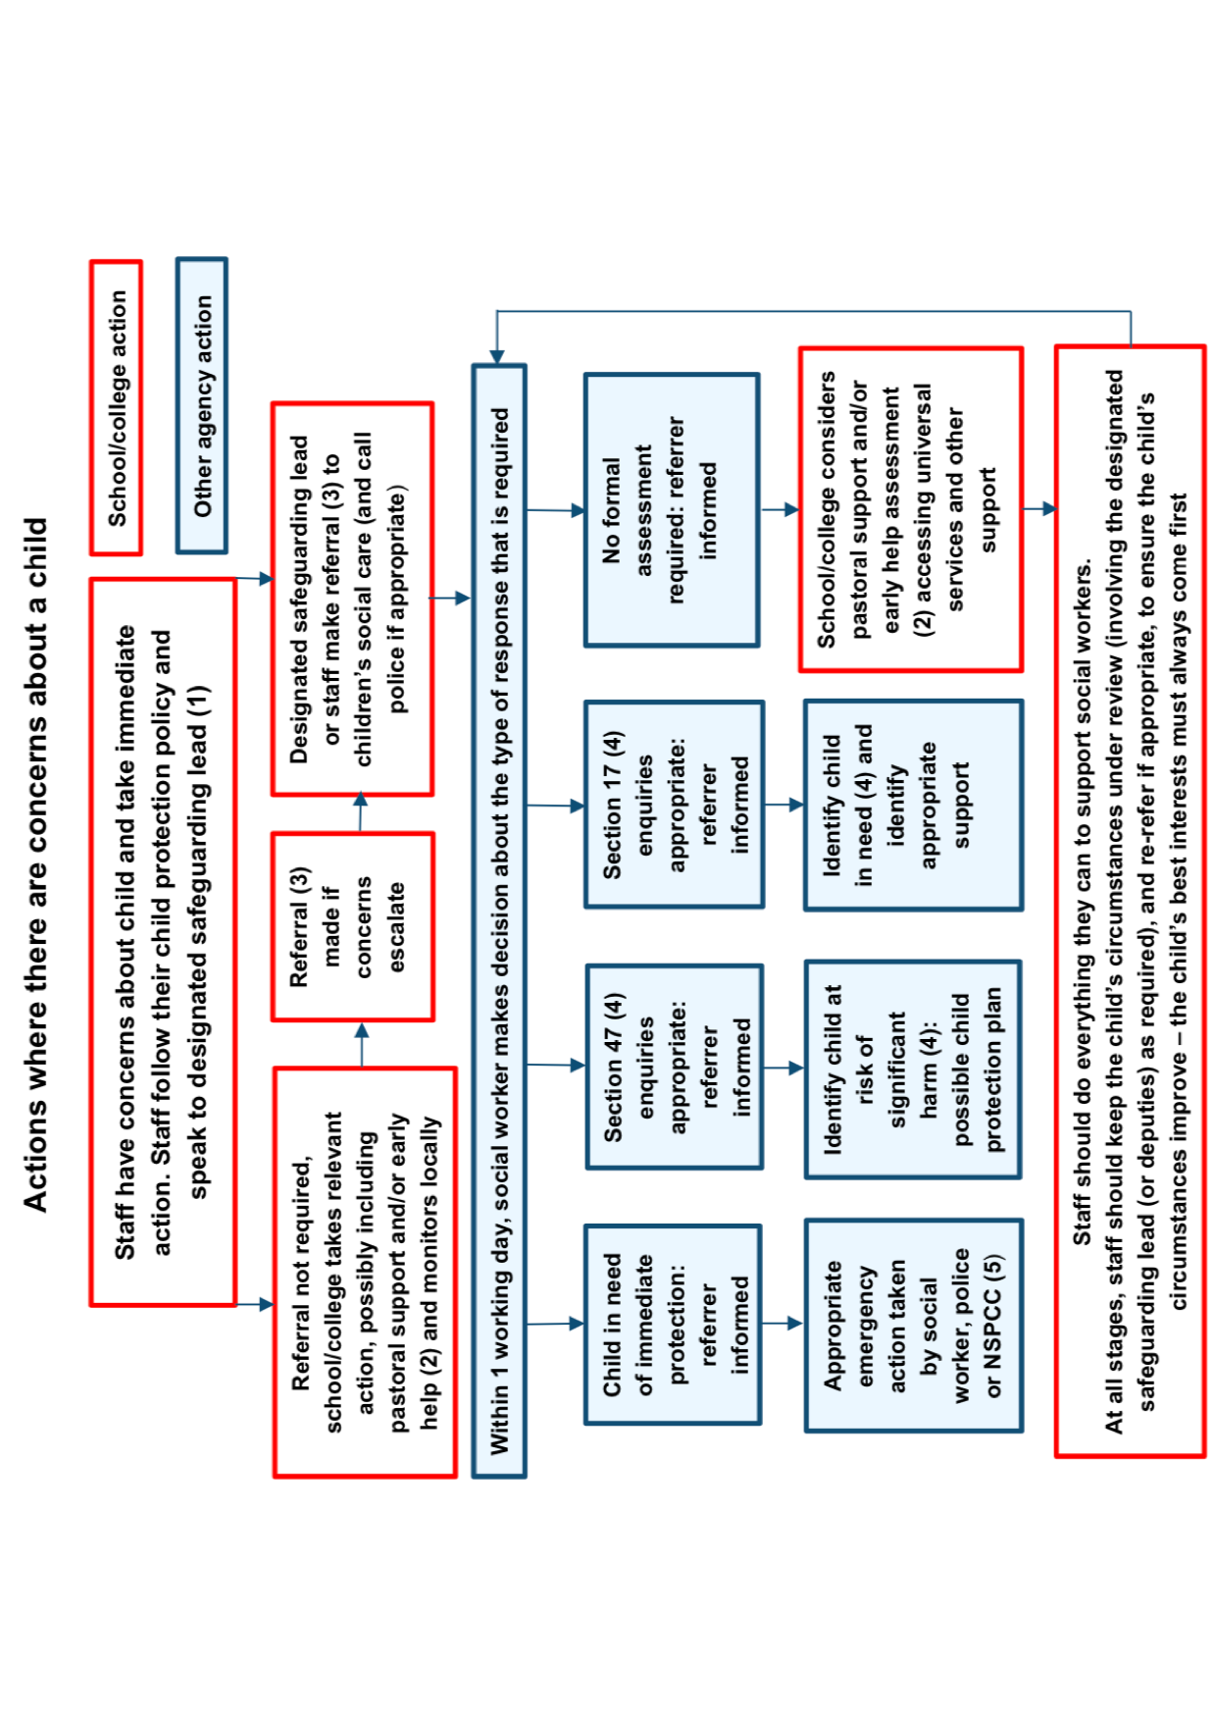

NB Section 17 is the same as Child in Need, section 47 is the same as Child Protection

Flowchart taken from ‘Keeping Children Safe in Education’ Sept 19

Early Help
What do we mean by Early Help?
Working Together to Safeguard Children (July 2018) explains that: -
'Providing early help is more effective in promoting the welfare of children than reacting later. Early help means providing support as soon as a problem emerges, at any point in a child’s life, from the foundation years through to the teenage years. Early help can also prevent further problems arising, for example, if it is provided as part of a support plan where a child has returned home to their family from care, or in families where there are emerging parental mental health issues or drug and alcohol misuse.’ (Chapter 1)
Effective early help relies upon local agencies, including education working together to:
- identify children and families who would benefit from early help;
- undertake an assessment of the need for early help; and
- provide targeted early help services to address the assessed needs of a pupil and their family which focuses on activity to significantly improve the outcomes for the pupil/student.

How are children and families identified for Early Help?
In our school staff are alert to the fact that early signs of abuse and/or neglect can be indicators that support is needed. In addition, the following children are more likely to require some form of early help:
- disabled children
- children with special educational needs
- young carers
- children displaying signs of antisocial or criminal behaviour
- in family circumstances presenting challenges, including family breakdown
- children who have returned home from care
What support is provided as part of the school's Early Help offer?
For families who are working in the Early Help pathway we offer a range of strategies to support them. This includes
- Financial support – snack money, school uniform, access to Food Vouchers
- Free family learning sessions to increase confidence and self esteem
- Drop in sessions for pupils in need as required
- Signposting to other services e.g. STEP. PCSO, Memory Makers, SMASH
- Family Support Work
How does the Early Help process work?
The Early Help Record and Plan is the common process in Swindon for supporting children, young people and families with additional needs through early identification, swift intervention and a planned, coordinated response. The aim is to consider the needs of the child or young person in four key areas:
- Health and Well-being
- Development needs, educational attainment and achievement
- Parenting/caring
- Family and Community
The intention is for all children and young people, irrespective of their circumstances, to have the best start in life, to grow up safe, stable and healthy, to fulfil their potential and make a contribution to their community.
Below is a flowchart outlining the process for working with a family in Early Help. At all times families and schools are supported by the Early Help Hub.

Making A Referral to Children's Social Care
Early Help may already have been started but with little impact or the concern is more complex than can be addressed with Early Help. At this stage consideration should be given to make a referral to Children's Social Care
- In the first instance this should be made by telephone 01793 466903 It is useful to have any safeguarding / child protection records to hand.
- Following a telephone referral, you will be required to submit a written referral within 24 hours. This will need to contain sufficient detail to provide a picture of what life is like for the pupil. Information should also be considered about any wider environmental factors (including links with other children) which pose a threat to the safety and welfare of the pupil. You may wish to attach a copy of the individual pupil chronology.
- If a referral to Social Care is going to be made by the school, invite the parent/carer into school to read the referral form through.

Support for The Pupil
A variety of strategies are employed within school to support pupils who have been referred to social care. Key members of staff support the children as appropriate (Safeguarding Team, TAs, Teachers, Lunch time staff). This often depends on who the child has a trusted relationship with. Other strategies include
- A named member of staff (that the child trusts) as contact for the child
- Drawing and Talking
- Talk Time
- Nurture/ ELSA
- A young carers group if appropriate.
See also
'What to Do If Worried About A Pupil/Student' - DfE March 2015"

Escalation
- If a member of staff does not see any improvement having reported a concern about a pupil, they have a duty to re-report to a member of the safeguarding team.
- If it is felt that the safeguarding team is not taking their concern seriously then this must be escalated to the Head teacher. See also section ‘Whistle-blowing’.
- If a member of the safeguarding team feels a decision made by another professional in another agency is not in the pupil’s best interests, they must discuss this further. In the first instance, this takes place directly with the professional involved to allow opportunity for decision-making to be discussed and clarified. (Pre-escalation)
- If pre-escalation fails to resolve the issues identified, the member of the safeguarding team should escalate within their own organisation (to the Head teacher if they are not in this role). The issue is then escalated to the professional's line-manager. (Escalation/Case Resolution)
- The Head teacher will ensure that the intention to instigate escalation procedures is made explicit and in writing.
- At all stages records should be kept.

Worried About the Actions of An Adult Who Works/Volunteers with Children
You may be worried about the actions of an adult who is working/volunteering with children because you have seen or heard something which makes you feel uncomfortable. You may be concerned that the adult’s actions are contravening the school’s staff code of conduct.
NB: School has adopted ‘Guidance for safer working practice for those working with children and young people in education settings May 2019’ as the school’s staff code of conduct.
All concerns must be reported following the steps below: -
Step 1
- If you are concerned that a pupil might be in immediate danger or at risk of significant harm you must act immediately. Do you need to take immediate action to secure the safety of the pupil?
- Report your concerns directly to the Head teacher (Mr Damian Booth) extension 217 as soon as possible.
- If the Head teacher is not contactable, report to the most senior member of staff on site.
- If your concerns are about the Head teacher report to the Chair of Governors directly. Mr Peter McGuigan pmcguigan@sevenfieldsprimary.org
Step 2
- Record your concerns using the school's 'Concern/Disclosure' form (see appendix 5) , as soon as possible..
- Remember to record the full date and time, your name and role and keep your record as factual as possible.
- If a concern/disclosure form is unavailable, handwritten notes can be made on a piece of paper. (This must be retained, even if the notes are subsequently written up onto the form).
Step 3
- Record what action you are taking, for example record the name of the member of staff you have reported to.
- The original concern form should be passed to the Head teacher or the Chair of Governors, if the concern/allegation involves the Head teacher. Copies should not be retained by you.
- If the person you have reported the concern to does not take your concern seriously, you must escalate your concern to the Chair of Governors. Ultimately anyone can report a safeguarding concern about an adult working with children into the local authority, asking to speak to the Local Authority Designated Officer (LADO) See Quick Reference Contact Guide on page 2.

What happens once a report about an adult working/volunteering with children is reported?

Step 1
- The Head teacher/ Chair of Governors will consider the information in the report and initial consideration will be given as to whether this indicates that the person would pose a risk of harm if they continue to work in close or regular contact with children in their present position or in any capacity.
This will be done by assessing whether there is evidence to suggest that: -

- the person has behaved in a way that has harmed a child, or may have harmed a child;
- the person has possibly committed a criminal offence against or related to a child; or
- the person has behaved towards a child or children in a way that indicates that he/she may pose a risk of harm to children

Criteria listed above taken from Part 4 of ‘Keeping Children Safe In education’ Sept 2019

Step 2
- If LADO involvement is not required, the Head teacher/Chair of Governors may need to complete their own enquiries to establish whether any further action is required e.g. additional training for adults involved, additional staff supervision required, risk assessment required. Written records must be made of the subsequent decision-making process and reasons for decision-making, together with actions and outcomes.

Step 3
- If it is decided that there is evidence to suggest the concern meets one or more of the above criteria the Head teacher /Chair of Governors should contact the LADO immediately.
Jon Goddard (LADO) - (Monday – Wednesday, 9am – 5pm) - 07392 103019
Rachel Hull (LADO) – (Monday to Friday, 9am – 5pm) 07392 103032.

Step 4
The LADO will decide on further action: -
- no further action after initial consideration and closure, or
- advice and follow up from LADO, or
- strategy discussion/meeting

If no further action by the LADO is agreed the school may be asked to complete their own enquiries and report the findings back to the LADO at the conclusion.

If further action is agreed, the LADO will agree with the police whether or not a strategy discussion/ meeting needs to take place. If it is agreed that the threshold has not been met for a strategy discussion/meeting, an allegations management meeting may be held. The main purpose of this is to ensure the safety of the children and ensure the process is concluded promptly, ensuring the accused staff member has adequate support.

All concerns raised about an adult working in the school, including allegations, are recorded and held confidentially. Where a strategy discussion/meeting has been held involving the LADO the school will be sent a copy of the minutes of the meeting.

Where an allegation is substantiated this will be referred to in any references provided by the school for the individual if and when they apply for new positions. If the adult is employed by an external agency, a copy of these records will be given to the senior lead of the organisation.

Employers have a duty of care for their employees. The Head teacher/Chair of Governors must put in place support for the adult at the centre of the concern/allegation. See further details in Chapter 4 page 54 of ‘Keeping Children safe In Education’ (Sept 2019)
.
Statutory requirements in relation to individuals who are on the barred list
At the end of the allegation process if a member of staff or volunteer is removed from their position for causing harm or posing a risk of harm or they leave whilst investigations are on-going, the school has a duty to inform the Disclosure and Barring Service via a referral.

We understand, as a school, that if we know or have reason to believe that an individual is barred, we are committing an offence if we allow the individual to carry out any form of regulated activity.
See also Chapter 4 Keeping Children Safe in Education (Sept 19)
See also DBS barring form
Specific Safeguarding Themes and Issues and Additional Actions Which May Need Considering

Neglect
What do we mean by neglect?
Working Together defines neglect as: -
'The persistent failure to meet a child's basic physical and/or psychological needs, likely to result in the serious impairment of the child's health or development. Neglect may occur during pregnancy as a result of maternal substance abuse. Once a child is born, neglect may involve a parent or carer failing to:
- provide adequate food, clothing and shelter (including exclusion from home or abandonment);
- protect a child from physical and emotional harm or danger;
- ensure adequate supervision (including the use of inadequate caregivers); or
- ensure access to appropriate medical care or treatment.
It may also include neglect of, or unresponsiveness to, a child's basic emotional needs.’

What are the indicators of neglect?
The following is a summary of some of the indicators that may suggest a child is at risk of or being neglected: -

Physical indicators of neglect
- Constant hunger and stealing food
- Poor personal hygiene - unkempt, dirty or smelly
- Underweight
- Dress unsuitable for weather
- Poor state of clothing
- Illness or injury untreated

Behavioural indicators of neglect
- Constant tiredness
- Frequent absence from school or lateness
- Missing medical appointments
- Isolated among peers
- Frequently unsupervised
- Stealing or scavenging, especially food
- Destructive tendencies

Swindon Borough council has published a Neglect Framework Guidance – click here to read

Peer on Peer Abuse
We recognise that children are capable of abusing other children. We understand that the pupil who is perpetrating the abuse may also be at risk of harm. We will make every effort to ensure that the perpetrator is also treated as a victim and supported appropriately.

What is peer on peer abuse?
Peer on peer abuse can take the form of: -

- Bullying (including Cyberbullying)

- ‘Cyberbullying’: involves sending inappropriate or hurtful text messages, emails or instant messages, posting malicious material online (e.g. on social networking websites) or sending or posting offensive or degrading images and videos
- Racist and Religious Bullying: A range of hurtful behaviour, both physical and psychological, that makes a person feel unwelcome, marginalised, excluded, powerless or worthless because of their colour, ethnicity, culture, faith community, national origin or national status;
- Sexual, Sexist and Transphobic Bullying: includes any behaviour, whether physical or non- physical, where sexuality is used as a weapon by boys or girls;
- Homophobic Bullying: targets someone because of their sexual orientation (or perceived sexual orientation);
- Disablist Bullying: targets a young person solely based on their disability, this can include manipulative bullying where a perpetrator forces the victim to act in a certain way or exploiting a certain aspect of the victim’s disability.

What action is taken in response to concerns about bullying?
Pupils who attend our school have the right to learn in safety. We do not tolerate bullying of any kind and will challenge derogatory language and behaviour towards others. The Anti-Bullying Policy outlines how the school acts to manage any bullying/friendship issues. The head teacher has overall responsibility for the policy and there is a named anti-bullying coordinator who has oversight of the anti-bullying strategy. The anti-bullying coordinator supports staff, parents and children in ensuring incidents are investigated thoroughly and fairly and then analyses incidents to identify any trends. Learning activities (taught through a range of activities e.g. assemblies, PSHE lessons) educate the children about what bullying is and what impact it has. The key message is that everyone has responsibility to tackle any bullying and uphold mutual values and acceptable behaviour.

- Child Sexual Exploitation
The definition of Child Sexual Exploitation (CSE) from the Department of Education (DfE, 2017) states that: -
“Child Sexual Exploitation is a form of child sexual abuse. It occurs when an individual or group takes advantage of an imbalance of power to coerce, manipulate or deceive a child or young person under the age of 18 into sexual activity (a) in exchange for something the victim needs or wants, and/or (b) for the financial advantage or increased status of the perpetrator or facilitator. The victim may have been sexually exploited even if the sexual activity appears consensual. Child sexual exploitation does not always involve physical contact; it can also occur through the use of technology.”
It is important to remember that there are different models of CSE (see section below on Exploitation), including peer on peer sexual exploitation. Many children are not aware of the exploitation as they have a genuine belief that they are loved by their boyfriend / girlfriend or are acting in accordance with their peers. They are often recruited into exploitation by those who they trust, those of a similar age and with similar hobbies. Often the nature of peer on peer exploitation encompasses a sense of peer pressure and wanting to fit in.

What action is taken in response to concerns that a pupil might be being sexually exploited by a peer?
Our normal safeguarding procedures will be followed here, and a referral made to social care as appropriate (including support for the pupil who is deemed to be 'perpetrating' the abuse.)

- Harmful Sexual Behaviour
Sexually harmful behaviour from children does not always occur with the intent to harm others. There may be many reasons why a child engages in sexually harmful behaviour and it may be just as distressing to the child who instigates it as well as the child it is intended towards. For this reason, consideration will always be given to how the child displaying the behaviour is supported, in addition to the 'victim' of the behaviour. This may include a referral to social care. Sexually harmful behaviour may range from inappropriate sexual language, inappropriate role play, to sexually touching another or sexual assault / abuse.
Taken from Tri.X 'Peer on Peer Abuse' Briefing 198 (Feb 2017)

What action is taken in response to concerns that a pupil has exhibited harmful sexual behaviour?
- Consider referring to the ‘Brook Sexual Behaviours Traffic Light Tool

- Our normal safeguarding procedures will be followed here, and a referral may be made to social care as appropriate, for both the pupil displaying the behaviours and also any pupil who has been involved and may have been harmed.
- If more than two incidents occur a Risk Assessment is completed to support the perpetrator and ensure that appropriate strategies are employed to reduce the risk of recurrence.

- Sexting
Harmful sexual behaviour also includes sexting when someone sends or receives a sexually explicit text, image or video. This includes sending ‘nude pics’, ‘rude pics’ or ‘nude selfies’. Pressuring someone into sending a nude picture may occur in any relationship and to anyone, whatever their age, gender or sexual preference. However, once the image is taken and sent, the sender has lost control of the image and these images could end up anywhere. By having in their possession, or distributing, indecent images of a person under 18 on to someone else, children are not even aware that they could be committing a criminal offence.
Taken from Tri.X 'Peer on Peer Abuse' Briefing 198 (Feb 2017)

Responding to A Sexting Incident
See also the UK Safer Internet Centre and SWGfL guidance 2016

Step 1 - If a device is involved, endeavour to secure the device and switch it off. Report immediately to the DSL or deputy DSL.
Step 2 - The DSL / deputy will consider the following:
- Significant age difference between the sender/receiver involved
- If staff recognise the pupil as more vulnerable than is usual (i.e. at risk)
- If the image is of a severe or extreme nature
- If the situation is not isolated and the image has been more widely distributed
- If this is not the first time the pupil has been involved in a sexting act
- If other knowledge of either the sender/recipient may add cause for concern (i.e. difficult home circumstances)

Step 3 - If these characteristics present cause for concern, then the DSL or deputy will escalate and make a referral to children’s social care. The police may also be contacted at this point.
Step 4 - A record of the incident will be made on CPOMs including actions taken / not taken and the justification for these decisions (linked to the points above).

- Sexual harassment and sexual violence
Sexual violence and sexual harassment can occur between two pupils of any age and sex. It can also occur through a group of pupils sexually assaulting or sexually harassing a single pupil or group of pupils. Definitions of sexual violence and sexual harassment can be found in the document listed below.
See also Sexual violence and sexual harassment between children in schools and colleges (May 18)

Responding to an incident of sexual harassment or sexual violence
Step 1 – Record the incident on CPOMs and report to the DSL / deputy in line with safeguarding and child protection procedures. Is information about the incident first hand or do other individuals need to be spoken to, to confirm?
Step 2 – The DSL will consider the following: -
- Ages of pupils/students / developmental stage
- Is there a power imbalance?
- One off or sustained pattern?
- Has a criminal offence been committed? If yes, contact the police
Step 3 - If there is no evidence to suggest that a criminal offence has taken place the DSL will consider next steps, in discussion with parents/carers unless to do so would increase the risk to the pupils involved. This may involve: -
- Dealing with internally under the school’s behaviour policy
- Considering Early Help support for both the victim and perpetrator (does the perpetrator have unmet needs?)
- Making a referral to children’s social care if the victim has been harmed, or is at risk of harm
- Making a referral to children’s social care if the perpetrator is at risk of harm / being harmed (under-lying welfare and safety concerns which may have triggered behaviours)

How does the school minimise the risk of peer on peer abuse?
Teaching and learning
This school provides a PSHE curriculum, Jigsaw, which develops pupils'/students' understanding of acceptable behaviour and keeping themselves safe. This curriculum is broad, balanced and covers a range of safeguarding themes. It is progressive across the year groups.
The themes are
- Being me in my world
- Celebrating difference
- Dreams and Goals
- Healthy me
- Relationships
From the Early Years onwards, children are taught about what to say and do if they don’t like something – from encountering strangers to bullying, and from unwanted physical contact to racism and being safe with technology. As ever, the emphasis is on helping children realise their independence and responsibility for themselves.
Reporting Procedures
The school's ethos encourages pupils to raise concerns with staff, knowing that they will be listened to, believed and valued. Children are encouraged to speak out to a trusted adult if they are worried about peer on peer abuse and are reminded about who they can speak to through displays in the school and posters advertising helplines e.g. Childline.
Expectations of behaviour
The school has a behaviour policy in place which is regularly reviewed and sets out the expectations about appropriate behaviour. Our school makes clear that sexual violence and sexual harassment is not acceptable, will never be tolerated and is not an inevitable part of growing up.
The positive behaviour policy outlines our approach to managing behaviour and how pupils are rewarded for acceptable behaviour and the sanctions that are actioned when their behaviour is unacceptable. The Head Teacher takes responsibility for monitoring concerning behaviour and work with parents to support children whose behaviour is regularly a concern.
It is an expectation of all staff that they take responsibility for managing behaviour, follow up incidents personally and use restorative approaches.
Risk Assessments
Risk Assessments may be written for pupils, who have been identified as being at increased risk of peer on peer abuse (considered for both the pupil perpetrating the abuse and the pupil who is the victim.)
These will be shared with the parent/carer and the pupils concerned.

Domestic Abuse
The government’s definition of domestic abuse is: -
‘Any incident or pattern of incidents of controlling, coercive, threatening behaviour, violence or abuse between those aged 16 or over who are, or have been, intimate partners or family members regardless of sexuality or gender. The abuse can encompass, but is not limited to: -
- Psychological
- Physical
- Sexual
- Financial; and
- Emotional

What action is taken in response to concerns that a pupil might be subject to or witnessing domestic abuse?
Where a member of staff or regular volunteer/visitor has a concern about a pupil in this situation or where a disclosure has been made to an adult working in the school, the school’s normal safeguarding and child protection procedures will be followed.
Reports of domestic abuse (involving pupils who attend this school) received by the police are sent by the MASH team to school via a secure system. This information is then added to the child’s chronology on CPOMs and a ‘sunflower’ discussion is undertaken with the child. In this discussion the child is encouraged to complete a sunflower of things that are going well, friendships and family and then any ‘worry worms’ they may have. The outcomes of this discussion are then shared with parents and if appropriate an Early Help Record/referral to social care will be offered.

Exploitation and Serious Violent Crime
This school recognises that children can be exploited sexually or criminally. They may be at risk of or involved in serious violent crime.
What is Criminal Exploitation?
There is currently no legal definition of child criminal exploitation (CCE) through organised crime groups in England and Wales. The criminal exploitation of children includes a combination of:
Pull factors: children performing tasks for others resulting in them gaining accommodation, food, gifts, status or a sense of safety, money or drugs;

Push factors: children escaping from situations where their needs are neglected and there is exposure to unsafe individuals, where there is high family conflict or the absence of a primary attachment figure.
Control: Brain washing, violence and threats of violence by those exploiting the child particularly when the child or young person is identified by the police, they are expected to take full responsibility for the offences for which they are charged – i.e. possession and supply of illegal substances.
The majority of children or young people who enter into exploitation do so willingly however, their involvement is indicative of coercion or desperation rather than choice. Many young people do not recognise that they are being exploited or that they are at risk.
As a school we are aware of the risks involved with a form of criminal exploitation known as ‘County Lines’. Children, as young as 10, are trafficked around the UK by organised gangs to deliver drugs.

What is Child Sexual Exploitation?
The definition of Child Sexual Exploitation (CSE) from the Department of Education (DfE, 2017) states that: -
“Child Sexual Exploitation is a form of child sexual abuse. It occurs when an individual or group takes advantage of an imbalance of power to coerce, manipulate or deceive a child or young person under the age of 18 into sexual activity (a) in exchange for something the victim needs or wants, and/or (b) for the financial advantage or increased status of the perpetrator or facilitator. The victim may have been sexually exploited even if the sexual activity appears consensual. Child sexual exploitation does not always involve physical contact; it can also occur through the use of technology.”

Indicators that a pupil may be at risk of or involved with serious violent crime include: -
- Unexplained gifts/new possessions - these can indicate pupils/students have been approached by/involved with individuals associated with criminal networks/gangs
- Increased absence from school
- Change in friendship/relationships with others/groups
- Significant decline in performance
- Signs of self-harm/significant change in wellbeing
- Signs of assault/unexplained injuries
What action is taken in response to concerns that a pupil might be being exploited?
Our normal safeguarding procedures will be followed here, and a referral made to social care as appropriate (including support, if applicable, for the pupil who is deemed to be 'perpetrating' the abuse.)

Female Genital Mutilation
What is Female Genital Mutilation?
FGM is a procedure where the female genital organs are injured or changed and there is no medical reason for this.
It is frequently a very traumatic and violent act for the victim and can cause harm in many ways.
The practice can cause severe pain and there may be immediate and/or long-term health consequences, including mental health problems, difficulties in childbirth, causing danger to the child and mother; and/or death.
Key points
- FGM is illegal in the UK. It is also illegal to take a British National or permanent resident abroad to undergo FGM or help someone who is trying to arrange to have FGM performed.
- FGM is an unacceptable practice for which there is no justification. It is child abuse and a form of violence against women and girls.
- FGM is prevalent in 30 countries. These are concentrated in countries around the Atlantic coast to the Horn of Africa, in areas of the Middle East, and in some countries in Asia.
- FGM is a deeply embedded social norm, practised by families for a variety of complex reasons. It is often thought to be essential for a girl to become a proper woman, and to be marriageable. This practice is not required by any religion.

Risk Factors
The most significant factor to consider when deciding whether a girl or woman may be at risk of FGM is whether her family has a history of practising FGM.
In addition, it is important to consider whether FGM is known to be practised in her community or country of origin. It is important not to make assumptions that all girls from these communities are at risk.
A parent may request permission for their child to travel overseas for an extended period. This is sometimes requested leading into or out of a school holiday (often the summer break).

What action is taken in response to concerns about Female Genital Mutilation?
If a girl has disclosed to you that she has been subjected to FGM or you have visual evidence of this, you must report it to the police.
(Teachers are required to report known cases of FGM in girls under 18 to the police under the mandatory reporting duty October 2015)

If a direct disclosure has not been made and there is no visual evidence, but you have concerns that the pupil may have been subject to or at risk of FGM the school's normal safeguarding procedures will be followed here.
This includes reporting your concerns to a member of the safeguarding team and putting your concerns in writing.

What happens once a concern /disclosure has been reported to a member of the safeguarding team?
The DSL or deputy DSL will follow the steps below to respond appropriately to the concern and safeguard the pupil/student: -
Step 1
- Consider the information of concern. This may mean referring back to check whether there is any previous information of concern for the pupil.
Step 2
- Check whether there are any risk factors present for the pupil/ family.
Step 3
- Where it is deemed appropriate to do so, speak to the parent or carer about FGM. Be sensitive to language differences.
Step 4
- At this stage consideration should be given to make a referral to Children's Social Care. In the first instance this should be made by telephone 01793 466903. It is useful to have any safeguarding / child protection records to hand. Following a telephone referral, you will be required to submit a written referral within 24 hours.

See also:
FGM Helpline: 08000283550
Email: fgmhelp@nspcc.org.uk

Multi-agency statutory guidance on FGM

Home Office Resource Pack - http://www.gov.uk/government/publications/female-genital-mutilation-resource-pack

Response to Concerns About A Pupil Who May Be at Risk of Radicalisation
What is radicalisation and extremism?
Radicalisation refers to the process by which a person comes to support terrorism and forms of extremism leading to terrorism.
Extremism is defined by the Government in the Prevent Strategy (March 2015) as:
Vocal or active opposition to fundamental British values, including democracy, the rule of law, individual liberty and mutual respect and tolerance of different faiths and beliefs. Also included in the definition is reference to extremism that calls for the death of members of our armed forces, whether in this country or overseas.

What are the concerns about radicalisation?
The current threat from terrorism in the United Kingdom includes the exploitation of vulnerable people, including children, to involve them in terrorism or in activity in support of terrorism.
The normalisation of extreme views may also make children and young people vulnerable to future manipulation and exploitation.

What are the indicators that may suggest a pupil is at risk?
- showing sympathy for extremist causes
- glorifying violence, especially to other faiths or cultures
- making remarks or comments about being at extremist events or rallies outside school
- evidence of possessing illegal or extremist literature
- advocating messages similar to illegal organisations or other extremist groups
- out of character changes in dress, behaviour and peer relationships
- secretive behaviour
- online searches or sharing extremist messages or social profiles
- intolerance of difference, including faith, culture, gender, race or sexuality
- work or writing that displays extremist themes
- attempts to impose extremist views or practices on others
- advocating violence towards others

The internet provides children and young people with access to a wide range of content, some of which is harmful. As a school we recognise that extremists use the internet, including social media, to share their messages.
See also: -
- online safety for information about filtering
- The Use of Social Media for Online Radicalisation (DfE July 15)

What action is taken in response to concerns that a pupil might be at risk of radicalisation?
This school is clear that this exploitation and radicalisation should be viewed as a safeguarding concern.
As a school we recognise that we have an important part to play in educating children about extremism and recognising when pupils start to become radicalised.
At Seven Fields Primary School we ensure that through our school vision, values, rules, curriculum and teaching
- We promote tolerance and respect for all cultures, faiths and lifestyles.
- The governing body also ensures that this ethos is reflected and implemented effectively in school policy and practice.
- Pupils who attend our school have the right to learn in safety. We do not tolerate bullying of any kind and will challenge derogatory language and behaviour towards others.
- Visitors who are invited to speak to pupils will be informed about our ethos and safeguarding procedures and relevant vetting checks are undertaken. We undertake due diligence to ensure that visiting speakers are appropriate. Speakers will be supervised at all times and will not be allowed to speak to children without a member of staff being present.

Our normal safeguarding procedures will be followed here, and a referral made to social care as appropriate.

In addition, the DSL / deputy DSL may consider making a referral to the local authority Channel Panel (seek advice from Children’s Social Care)
Channel is a multi-agency approach to provide support to individuals who are at risk of being drawn into terrorist related activity. Each local authority has a panel and it aims to:
- Establish an effective multi-agency referral and intervention process to identify vulnerable individuals;
- Safeguard individuals who might be vulnerable to being radicalised, so that they are not at risk of being drawn into terrorist-related activity; and
- Provide early intervention to protect and divert people away from the risks they face and reduce vulnerability.

The DfE helpline can be contacted for advice 020 7340 7264 (this should not be used in cases of emergency)
or via the email counter.extremism@education.gsi.gov.uk

Additional Support for Pupils
Pupils with special educational needs and disabilities
As a school, we recognise that pupils who have special education needs and disabilities can face additional safeguarding and child protection challenges. These can include: -
- assumptions that indicators of possible abuse such as behaviour, mood and injury relate to the pupil’s disability without further exploration
- pupils with SEN and disabilities can be disproportionately impacted upon by things like bullying, without outwardly showing any signs
- communication barriers and difficulties in overcoming these barriers
Supporting pupils with mental health issues
Some pupils can be more vulnerable than others to issues such as depression, anxiety, self-harm or eating disorders. In school we need to be particularly vigilant about pupils who have experienced abuse, bullying, bereavement, have learning difficulties or are in care, as these circumstances can impact on their mental health.
Signs of possible mental health issues include: -
- noticeable weight loss or gain
- physical injuries
- change in personality e.g. mood swings
- frequently missing lessons
- social isolation
- lethargy and disinterest
- tearfulness or appearing anxious
- lack of focus in class
- change in educational performance

The school does everything it can to support pupils with mental health issues. The school is very aware of how important it is to support the children’s mental well-being and the Jigsaw PSHE scheme focuses on well-being as the lynchpin of every Jigsaw lesson. Support and resources for staff can also be found at Young Minds.

To support individuals the school uses a number of strategies including
- Early Help Practitioner: From September 2019 Seven Fields is working with a trainee Early Help practitioner as part of the TrailBlazer Programme which is a government funded programme to support mental health in schools. They will work with children, parents and staff to support healthy mental health. To find out more visit Who are EMPHs?

- Talk time: A chance for children to explore their emotional well-being with trained members of the team

- Memory Makers: This service supports children who have experienced loss that may have impacted on their emotional well being

- STEP: This can support child with confidence, self-esteem, friendships and making positive choices

- SEMH team: Where appropriate a referral can be made to the SEMH team who work with the child/staff in school to support a child’s emotional well-being

- TAMHs: A referral to TAMHs can be undertaken when the need is more complex and requires specialist provision. Should TAMHs consider it necessary then they can escalate the referral to CAMHs.
Intimate Care
Intimate care includes any tasks that involve the dressing and undressing, washing including intimate parts, helping someone use the toilet, changing nappies or carrying out a procedure that requires direct or indirect contact to an intimate personal area.
This level of care is given to children within a range of agreed procedures such as those within the Medical Needs Policy and Individual Care Plans. An intimate care policy is available to outline procedures for intimate care.
This level of care is given in supervised situations after staff training has been completed. It has a high regard of the rights and sensitivities of the individual. Their dignity must be safeguarded.
Looked After Children and Previously Looked After Children
The designated teacher for looked after children and previously looked after children is Sue Kershaw. The school staff work with multi-agency professionals, including the Local Authority Virtual Schools Head, to ensure that prompt action is taken when necessary to safeguard these children. We recognise these children are a particularly vulnerable group.

Appropriate staff are provided with information in relation to their legal status and contact arrangements, as well as information about the child’s care arrangements.

Behaviour and Attendance
As a school we recognise that there can be links between safeguarding and child protection concerns and: -
- incidents of disruptive and challenging behaviour
- poor attendance
Both of these aspects can be indicators that a pupil may be experiencing one or more forms of abuse.

Behaviour
Incidents of unacceptable behaviour are monitored on a daily basis by the completion of incident forms. These are then sent to our Inclusion Manager who supports class staff in managing sanctions. The inclusion manager reports to the deputy head who monitors incidents and reviews individual children to see if specialist support is required to support them with their behaviour. Behaviour logs are then added to children’s individual safeguarding chronologies to ensure individual trends and actions are recorded and reviewed.
See also the school’s pupil behaviour policy.

Positive handling of pupil/students
Where physical intervention is required to keep a pupil safe the school will respond in line with the DfE guidance 'Use of reasonable force' July 2013.
As a school we may intervene to: -
- prevent a pupil from attacking a member of staff or another pupil, or to stop a fight in the playground; and
- restrain a pupil at risk of harming themselves through physical outbursts.
Seven Fields uses a Team Teach approach when dealing with incidents involving positive handling. Team Teach Techniques seek to avoid injury to the service user, but it is possible that bruising or scratching may occur accidentally, and these are not to be seen necessarily as a failure of professional technique, but a regrettable and infrequent ‘side-effect’ of ensuring that the service user remains safe. All incidents of restraint are recorded in the school's bound book and reported to parents/carers.

All incidents of positive handling are recorded in the school's bound book and reported to parents/carers. Where a pupil has safeguarding /child protection records in place, information about incidents of positive handling will be cross-referenced on CPOMs. The bound book is available from the school office.
Where pupils require regular handling and intervention a positive handling plan will be put in place. The pupil, together with the parents/carers will be involved in this process.

Attendance
As a school, we recognise the importance of pupils attending school regularly. Any unexplained absence is followed up on the first day of absence. Where possible, we hold more than one emergency contact telephone number for each pupil/family.
Pupil attendance is monitored by the attendance in the school office on a daily basis. We recognise that children with poor attendance or missing from education may be more vulnerable and potentially are exposed to higher degrees of risk. Attendance information is therefore considered within the wider remit of safeguarding and child protection. Staff are aware that episodes of unexplained absence could indicate safeguarding concerns or the need for early help support.
Monitoring reports are supplied to the EWO and the Head Teacher regularly and to the Board of Governors. The Monitoring of the attendance of children who are in Care is reported daily to the Virtual School in Swindon.

See also 'Early Help
See also the local authority’s guidance on ‘Children Missing Education’

Pupils who are educated off site
Where pupils are attending off-site alternative provision, it is our responsibility to ensure that they continue to be kept safe. Quality assurance of any provision used by our school is completed prior to the placement of a pupil. This includes: -
- review of the provision’s safeguarding and child protection procedures
- a visit to the site.
- a letter of assurance to confirm that all staff working at the alternative provision have had the appropriate recruitment checks

For each day that the pupil attends the off-site provision contact is made by the attendance clerk in the office, to ensure they have arrived safely. This process also applies where a pupil has been excluded from school, including fixed term exclusions. Contact will be made with a parent or carer to confirm their safety on each day of the exclusion.

Part 2 – Policy
How is the information in this set of policy and procedures disseminated?
To ensure that staff have up to date access to the information in the Safeguarding Policy and Procedures there is a dedicated Safeguarding folder on the Google Drive within the school which is reviewed on a regular basis. Staff are also informed by email when updates have been added. There are also termly bite size training sessions where the policy is referred to.

Our staff induction programme includes a safeguarding section.
New staff
- Meet with the Designated Safeguarding Lead on joining the school
- Are asked to either undertake face to face training or on-line safeguarding training through The Safeguarding Network if they join the school mid-year. (If they join in September they are trained alongside existing staff in the Basic Awareness annual training led by the DSL).
- Undertake PREVENT training from the Home Office
They are also asked to read the following documents
- Safeguarding policy and procedures
- KCSIE education part 1 and annex A
- Read the staff Code of Conduct (Safer Working Practice 2019)
- The Whistleblowing policy
- Internet Safety Policies including the Acceptable Use Policy and Mobile Device policy

Visitors, volunteers and external staff who visit our school are asked to read a shortened version of the policy and procedures and undertake basic understanding of Safeguarding training with the DSL
Records are kept to document staff and visitor commitment to working in line with these procedures.

How do we ensure parents and carers understand the school's role in safeguarding pupils/students?
This school is committed to helping parents/carers understand its responsibility for the welfare of all pupils and our duty of care.
The policy and procedures are available to parents and carers via the school website and a paper copy can be requested by contacting the school office.

During pupil induction meetings for parents and carers information will also be discussed about the school's safeguarding responsibilities.

Roles and Responsibilities
It is the role of the Governors to ensure that all statutory duties with regard to safeguarding and child protection are fulfilled, as detailed in 'Keeping Children Safe in Education' (Sept 19).
The school completes an annual audit of safeguarding, in partnership with the link safeguarding Director. This self-evaluation is quality assured with a visit from an independent consultant. Where weaknesses or areas for development are identified, the Governors monitor the implementation and impact of identified actions to address these issues.
The Governors have a responsibility to ensure this policy and set of procedures are fit for purpose and known to all staff and regular volunteers.
The Head teacher provides a safeguarding report as part of the Headteacher’s report to Governors and the DSL meets with the Safeguarding Director on a regular basis (at least 3 times per year).

Where external organisations use the school premises, both within the school day and outside of school hours, the Governing Body has a responsibility to: -
- seek assurance that the body concerned has appropriate policies and procedures in place in regard to safeguarding pupils/students
- ensure that the appropriate level of safer recruitment checks have been completed on staff working for the organisation.

Record-keeping
Any member of staff, visitor or volunteer who has a concern about a pupil’s welfare or receives a disclosure of abuse will make an accurate record, as soon as possible, noting what was said or seen, putting the event into context and giving the full date, time and location. This will be noted on CPOMs. If injuries or marks have been observed which cause concern, these should be recorded on a body map outline, giving an indication of size and whether there is a defined shape to the mark or injury.
Staff will not take photographs.
Any handwritten notes (not captured on concern form) will be retained, even if they are subsequently written up.
Records of concern or disclosures will be kept (even if there is no need to make a referral immediately). These records are uploaded to CPOMs where they are stored confidentially. They do not form part of the pupil’s educational records and are stored separately. Confidentiality will be maintained and information relating to individual pupils/families shared with staff on a need to know basis.

Individual pupil files
Individual files are held on CPOMs for all children in the school and any concerns and disclosures are recorded on this digital system. CPOMs creates a chronology for each pupil and reviews of children are completed on a regular basis. All 'significant events' are captured on CPOMs, including attendance at meetings, phone calls and emails in relation to safeguarding and /or child protection matters. This chronology also captures headline information about what action has been taken and the outcome of this action. The outcome should focus, where possible, on the pupil and indicate whether the situation is improving.

Case file review
Safeguarding and child protection files for individual pupils are re-visited regularly to ensure any risk is being reduced and appropriate action taken. It is good practice for this review to take place on a termly basis.
To ensure that all files are reviewed an overview of all pupils (where there are safeguarding / child protection concerns) is kept up to date. This is a 'live' document and reflects the numbers of pupil/student’s subject to child protection, child in need or receiving early help support.

Transfer of records when a pupil moves to a new school
When a pupil moves school, safeguarding / child protection documentation will be passed as soon as possible and confidentially to the receiving school, separate from academic records. Where possible, the DSL will arrange to meet the DSL of the new school to discuss the documentation. The receiving school is asked to sign to confirm receipt of the information and this confirmation is stored on file.
The school will retain records for pupils who have been withdrawn to be home-schooled, if there is an existing safeguarding /child protection file. These will be stored confidentially in line with the local authorities record retention policy (until the pupil’s 25th birthday).

Safer Recruitment Procedures
This school works in line with Part 3 of Keeping Children Safe in Education (Sept 2019).
Checks completed on all staff and regular volunteers
- An enhanced DBS certificate, which includes barred list information, is required for any staff who will be engaging in regulated activity (working unsupervised with children). This is required for any staff employed since 2002. Prior to this staff were checked against List 99.
- Identity checks are completed, together with proof of right to work in the UK
- Qualifications are checked
- If an individual has lived or worked outside of the UK an overseas police check / certificate of good conduct may be required. A check of visa/work permit will also be required here.

In addition, staff who have a teaching role will be checked, via the DfE Secure Access Website, for
- qualified teacher status
- prohibition check
- section 128 check (for any individual who has a managerial role, including Governors and Trustees in academies and independent schools)
- completion of induction
- teacher not subject to a conditional offer/suspension
- European Economic Area sanctions

Visitors and externally employed staff
Where staff from external organisations are working with our pupils, we ensure that the letter of assurance received confirms that the relevant checks are in place, including a barred list check if the individual is working in regulated activity. Visitors are asked to provide proof of identity and if required, DBS information.

Single Central Record
The school maintains an up to date single central record of all safer recruitment checks. This is in line with the requirements as set out in Keeping Children Safe in Education (Sept 19). The DSL monitors this record termly and ensures it is in line with statutory requirements (Part 3 ‘Keeping Children Safe in Education’ Sept 19). The head teacher and safeguarding governor are kept informed that the school is meeting its statutory requirements.

Induction of new staff
Following appointment, the school offers new staff a programme of safeguarding and child protection induction. This includes: -
- Meet with the Designated Safeguarding Lead on joining the school
- Are asked to undertake on-line safeguarding training (Face to face with DSL or Introduction to Safeguarding online via the Safeguarding Network)or attend the annual Basic Safeguarding Training if joining in September.
- Read the safeguarding policy and procedures
- Read the staff Code of Conduct
- Read Internet Safety Policies
- The Acceptable Use Policy

Childcare Disqualification Checks
The ‘Disqualification Under the Childcare Act 2006 states that: -
‘Schools are responsible for ensuring that anyone who falls within the relevant categories of staff described in the staff covered and staff who may be covered sections is made aware of the legislation. Schools must make these staff aware of what information will be required of them and how it’ll be used to make decisions about disqualification. Schools are free to decide how to bring these requirements to the attention of their staff. As a means of making staff aware of their duty to provide such information, they may, for example, choose to include a section in the school’s safeguarding policy, or another policy document, or by means of an addition to new staff members’ contracts of employment. Schools should draw this guidance to the attention of their staff and the information provided by Ofsted referenced in this guidance.’
Staff are made aware of this guidance when they are recruited during pre-employment checks and the information is recorded on the schools Single Central Record .

Online Safety
What are the school's responsibilities around online safety?
'Keeping Children Safe in Education' (Sept 19) highlights that: -
‘Governing bodies and proprietors should ensure that children are taught about safeguarding, including online safety.’

In addition, the DfE have also published ‘Teaching Online Safety In Schools’ (non-statutory guidance).

This school recognises: -
- the increasing role technology has to play in education and children's daily lives
- the wide range of content which is available to children via the internet
- that alongside the benefits of technology, there are also risks
- the importance of delivering a broad and relevant online safety curriculum which provides progression across year groups
- that delivery of this curriculum must be provided via regular lessons, which take place throughout each term
- the importance of keeping up to date with the tools, apps and devices children are using so that the curriculum which is offered is meaningful.

What our online safety curriculum offers
Key online safety messages such as the SMART rules
- Safe – Don’t give out personal information
- Meeting- Only meet people you’ve met online with parent’s knowledge
- Accept – don’t accept emails, messages files etc from people you don’t know
- Reliable -Don’t trust everyone you see online
- Tell – Tell someone if you see something that makes you uncomfortable online
are reinforced at every opportunity across the curriculum, in assemblies, PSHE lessons and during taught Computing lessons.

- Pupils are taught in all lessons to be critically aware of the materials and content they access on-line and understand that not everything they see online is true
- Pupils are supported in building resilience to radicalisation. A safe environment is provided for debating controversial issues and helping them to understand how they can influence and participate in decision-making.

Filters and monitoring
Internet access is filtered for all users. Illegal content (child sexual abuse images) is filtered via RM SafetyNet by actively employing the Internet Watch Foundation CAIC list. Content lists are regularly updated
Internet filtering should ensure that children are safe from terrorist and extremist material when accessing the internet.
Appropriate security measures are in place to protect the servers, firewalls, routers, wireless systems, workstations, mobile devices etc from accidental or malicious attempts which might threaten the security of the school systems and data. The school infrastructure and individual workstations are protected by up to date virus software.

Use of mobile technology
The School allows staff to bring in personal mobile telephones and devices for their own use. Under no circumstances does the school allow a member of staff to contact a pupil or parent / carer using their personal device.
Users bringing personal devices into school must ensure there is no inappropriate or illegal content on the device.
All staff must ensure that their mobile telephones / devices are left inside their bag throughout contact time with children.
Mobile phone calls may only be taken at staff breaks or in staff members’ own time.
If staff have a personal emergency, they are free to make a personal call from their mobile in the staffroom or admin area.
If any staff member has a family emergency or similar and required to keep their mobile phone to hand, prior permission must be sought from a member of the leadership team and the mobile phone should be placed in a safe place (out of the reach of the children) within the classroom.
Staff need to ensure that the school office has up to date contact information and that staff make their families, children’s schools etc. Aware of emergency work telephone numbers. This is the responsibility of the individual staff member.
All parent helpers / students will be requested to place their bag containing their phone in a locker or another appropriate location and asked to take or receive any calls in the staffroom / admin areas.
During class outings nominated staff will have access to the school’s nominated mobile phone, which is to be used for emergency purposes only.
It is the responsibility of all members of staff to be vigilant and report any concerns to the Head Teachers. Concerns will be taken seriously, logged and investigated appropriately.
The Head Teacher or Deputy Head in their absence reserves the right to check the image contents of a member of staff’s mobile phone should there be any cause for concern over the appropriate use of it.
Should inappropriate material be found then our Local Authority Designated Officer (LADO) will be contacted immediately. We will follow the guidance of the LADO as to the appropriate measures for the staff member’s dismissal.
Safeguarding Supervision
All staff working in this school have a responsibility to safeguard the children in their care. Staff can only achieve this effectively if they: -
• are clear about what is expected of them
• have the skills, knowledge, behaviours, values and attitudes to carry out their role
• are fully supported in their role and managed effectively

Safeguarding supervision is available for any member of staff as required. Members of the safeguarding team receive planned safeguarding supervision three times per year.

Whistleblowing
This school expects the highest standards of conduct from all employees and Governors and will treat seriously any concern raised about illegal or improper conduct. The law provides protection for employees who raise legitimate concerns about specified matters. These are called ‘qualifying disclosures.’ A qualifying disclosure is one made in the public interest by the employee who has a reasonable belief that:

a criminal offence
a miscarriage of justice
an act creating risk to health and safety
an act causing damage to the environment
a breach of any legal obligation
a concealment of any of the above

is being, has been, or is likely to be, committed. It is not necessary for the employee to have proof that such an act is being, has been, or is likely to be committed, a reasonable belief is sufficient. The employee has no responsibility for investigating the matter; it is the school’s responsibility to ensure that an investigation takes place.

Staff and volunteers are encouraged to raise concerns about poor or unsafe practice and potential failings in the school's safeguarding regime via: -
- the staff code of conduct
- the visitor's/volunteer's code of conduct

In the first instance, unless the employee reasonably believes their Head teacher to be involved in the wrongdoing, any concerns should be raised with the employee’s Head teacher. If he/she believes the Head teacher to be involved, then the employee should proceed straight to the Chair of Governors.
Where a member of staff feels unable to raise a concern with either of the individuals identified above, the NSPCC whistle-blowing helpline is available to them.

Training for Adults Working in Our School
We are committed to ensuring staff and volunteers know and understand: -
- the signs and symptoms of abuse;
- how to identify pupils/students who may benefit from early help;
- their responsibility for referring concerns to the designated safeguarding lead / deputy;
- the procedures for reporting safeguarding /child protection concern about adults working with children (allegations)

Formal training
Safeguarding and child protection training is provided to all staff to enable them to carry out these requirements. This is basic awareness of safeguarding and child protection and includes the possible signs and indicators of abuse and how to respond effectively. Staff also undertake Radicalisation and the Prevent Duty training on joining the school.

Volunteers receive a shortened version of the basic awareness training package when joining the school. They also have the opportunity to meet the DSL and raise any questions.

Governors are requested to complete the online basic awareness training from the Key on joining the board.

Updates
In addition to formal training, all staff receive regular opportunities to update their knowledge and understanding.
These updates include a focus on: -
- Early Help
- Female Genital Mutilation
- Exploitation, including child criminal exploitation and child sexual exploitation
- Child mental ill-health
- Parent mental ill-health
- Domestic abuse
- Online safety
- Forced marriage and honour-based violence
- Child-trafficking
- Sexual harassment and sexual violence

These are delivered by email, discussion regarding scenarios and staff meetings. There is an annual session with all staff, in September that covers basic understanding of Safeguarding/Child Protection procedures and policies. Staff also undertake online training regarding PREVENT.

Additional training for Designated Safeguarding Leads and deputy DSLs
The statutory requirement for DSLs and deputy DSLs is to renew training every 2 years. We work in line with this requirement.
Our deputy DSLs have completed advanced training to the same level as the DSL, in line with the requirements of our Local Authority.

In addition, the members of our safeguarding team complete: -
- FGM training
- Prevent training in line with statutory requirements
- LSCB L3 update training during the academic year when renew training is not required

Reading Requirements
All staff are required to read: -
- Part 1 of Keeping Children Safe in Education (Sept 19)
- Annex A of Keeping Children Safe in Education (Sept 19)
- the school's safeguarding and child protection policy and related policies
- the school's staff code of conduct
- the pupil behaviour policy
- the safeguarding response for children missing in education
- the role of the designated Safeguarding Lead and deputy/deputies
- the acceptable use policy

Staff are asked to sign to confirm their understanding and accept responsibility for following up any questions or queries they have arising from reading this document (with a member of our safeguarding team).

Regular volunteers are asked to read: -
- Part 1 of Keeping Children Safe in Education (Sept 19)
- The code of conduct for volunteers
- Information about what to do if worried about a pupil/adult working or volunteering with children

See also 'Safer Recruitment' for information about staff induction

Appendix 1
This policy and set of procedures work in line with the following legislation, statutory guidance and non- statutory guidance: -

Legislation

- The Education Regulations (Independent School Standards) 2014 - Independent schools including academies and free schools

Statutory Guidance

- Keeping Children Safe in Education (DfE Sept 2019)

- Working Together to Safeguard Children (DfE July 2018)

- Multi-agency statutory guidance on Female Genital Mutilation (April 2016)

- The Early Years’ Framework (April 2017)

- Sexual violence and sexual harassment between children in schools and colleges (May 2018)
- Relationships Education, Relationships and Sex Education and Health Education (statutory as of Sept 2020)

Non-statutory Guidance

- What to do if you are worried a child is being abused (DfE March 2015) - (non-statutory guidance)
- The Prevent Duty - Departmental advice for schools and childcare providers (DfE June 15)
- Information-sharing: advice for practitioners providing safeguarding services (DfE July 218)
- Children Missing Education (Sept 16)
- Teaching Online Safety in School (June 2019)
- Safer Working Practice Guidance for Adults Working with Children and Young People (May 2019)

In addition, the school takes into account: -

- Regional guidance
- the procedures and practice of the local authority

Appendix 2 – Definitions of Abuse (taken from Working Together July 2018)
Physical Abuse
A form of abuse which may involve hitting, shaking, throwing, poisoning, burning or scalding, drowning, suffocating or otherwise causing physical harm to a child.
Physical harm may also be caused when a parent or carer fabricates the symptoms of, or deliberately induces, illness in a child.

Neglect
The persistent failure to meet a child’s basic physical and/or psychological needs, likely to result in the serious impairment of the child’s health or development. Neglect may occur during pregnancy as a result of maternal substance abuse.

Once a child is born, neglect may involve a parent or carer failing to:
- provide adequate food, clothing and shelter (including exclusion from home or abandonment);
- protect a child from physical and emotional harm or danger;
- ensure adequate supervision (including the use of inadequate caregivers); or
- ensure access to appropriate medical care or treatment.

It may also include neglect of, or unresponsiveness to, a child’s basic emotional needs.

Emotional Abuse
The persistent emotional maltreatment of a child such as to cause severe and persistent adverse effects on the child’s emotional development. It may involve conveying to a child that they are worthless or unloved, inadequate, or valued only insofar as they meet the needs of another person. It may include not giving the child opportunities to express their views, deliberately silencing them or ‘making fun’ of what they say or how they communicate. It may feature age or developmentally inappropriate expectations being imposed on children. These may include interactions that are beyond a child’s developmental capability, as well as overprotection and limitation of exploration and learning, or preventing the child participating in normal social interaction. It may involve seeing or hearing the ill-treatment of another. It may involve serious bullying (including cyber bullying), causing children frequently to feel frightened or in danger, or the exploitation or corruption of children. Some level of emotional abuse is involved in all types of maltreatment of a child, though it may occur alone."

Sexual Abuse
Involves forcing or enticing a child or young person to take part in sexual activities, not necessarily involving a high level of violence, whether or not the child is aware of what is happening. The activities may involve physical contact, including assault by penetration (for example, rape or oral sex) or non-penetrative acts such as masturbation, kissing, rubbing and touching outside of clothing. They may also include non-contact activities, such as involving children in looking at, or in the production of, sexual images, watching sexual activities, encouraging children to behave in sexually inappropriate ways, or grooming a child in preparation for abuse (including via the internet). Sexual abuse is not solely perpetrated by adult males. Women can also commit acts of sexual abuse, as can other children.

\

Appendix 3
Safeguarding and Child Protection
Concern / Disclosure / Incident
CONFIDENTIAL
CPOMs
All staff have a personal logon for CPOMs and record incidences on the ‘add incident’ screen.

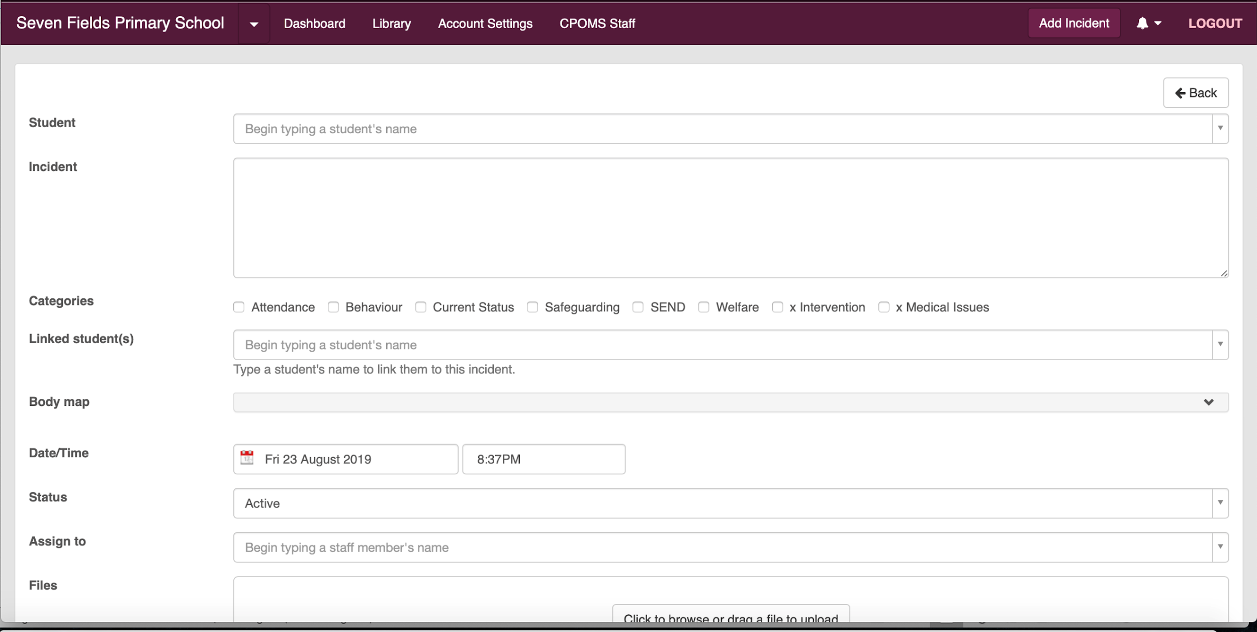

When receiving an incident alert, a member of the safeguarding team will
- Discussion of next steps agreed within the team
- Give reason(s) for the decision or action by the team
- Record any discussions with another professional, external to the school (giving full name/ role and agency)
- Detail any decision / action agreed by DSL or deputy:
- Identify if the local authority threshold guidance been referred to at this point?
- Ensure that the person who reported the initial concern been provided with feedback.
- Identify whether the child needs to be monitored and ensure the case is monitored at the next supervision discussion
- Identify whether Early Help support is appropriate?
- Identify whether a referral to children’s social care required and if the threshold for significant harm has been met (Child Protection).

Where staff don’t have access to CPOMs they can record on a ‘yellow sheet’ and it will be added to CPOMs by the safeguarding team
Disclosure/Concern Form (the yellow form)

Date: |  | Name and role of person completing form
Time: |  | Date and time read by DSL / Deputy DSL
Name of pupil/student: |  | DOB:
Location (if applicable)
What have I seen/heard/noticed which concerns me?

What am I worried about?

Is this concern linked to any previous concerns I have reported?

Action I have taken

Appendix 4
Safeguarding and Child Protection
Prompt sheet

This form is intended to be used, alongside the concern/incident form/CPOMs, to support staff with the recording of safeguarding and child protection concerns/incidents.

Have you remembered to include? -

- What is it that you have seen/heard/noticed which concerns you? Remember if you have noticed a mark on the pupil/student, it is really important to complete an attached body map, giving an indication of the shape, size and location of the mark.

- Clear and factual information about what you have seen/heard/noticed? If you have included your opinion in your report, have you made it clear that this is your opinion?

- Full names of those involved and where possible, reference to staff roles?

- Why what you have seen/heard/noticed concerns you? What are worried will happen if this concern/incident is not responded to?

- Any actions you have already taken?

- Whether you have spoken to parents/carers about the concern/incident? Remember, you may need to seek advice from a member of the safeguarding team if you are unsure about whether speaking to the parent may increase the risk to the pupil/student. If the parent is the alleged perpetrator you must always seek advice from the safeguarding team before speaking to the parent/carer.

Appendix 5
Concern / Disclosure regarding a member of staff
CONFIDENTIAL

Date: |  | Name and role of person completing form
Name of staff member causing concern |  | Date and time read by Headteacher/Chair of Governors
Location (if applicable)
What have I seen/heard/noticed which concerns me?

What am I worried about?

Is this concern linked to any previous concerns I have reported?

Swindon Borough Council Procedures for Management of Allegations against staff or volunteers who work with children
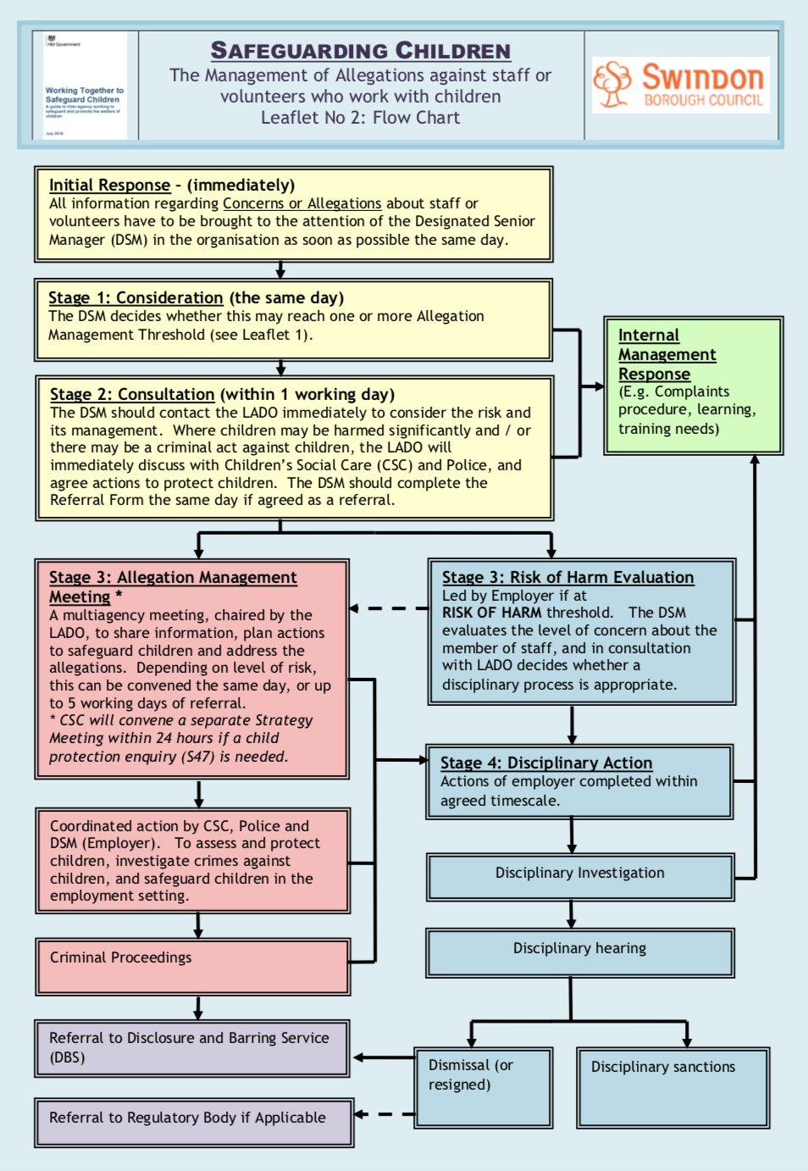
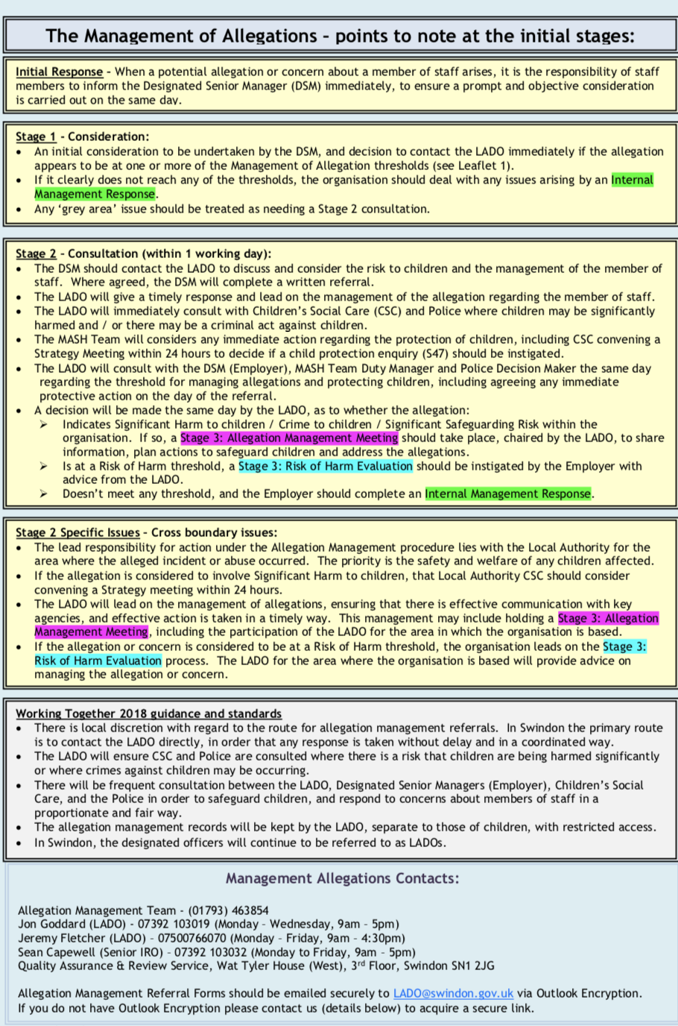This document was last reviewed and updated on 1st September 2019
The next scheduled review of this document is September 2020

Signed:……………………………………..(Head teacher)

Date:

Signed:……………………………………….(Chair of Governors)

Date

