Out of this World Homework!
Pick 3 of these projects to complete and earn 1 house point for each project. Bring your projects in on Wednesday 14th October.
Design and create a rocket.  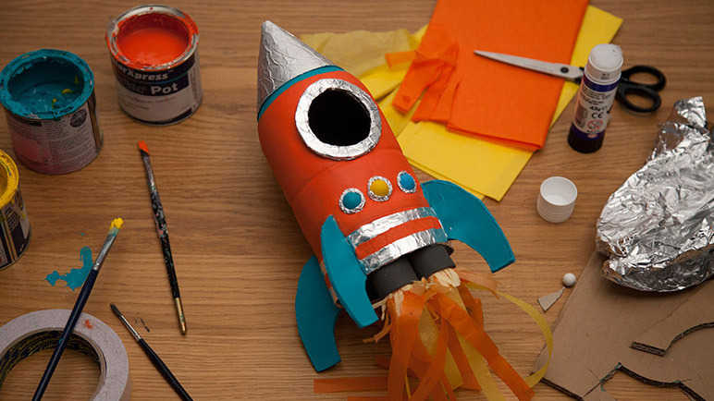 | Write a diary entry as if you were an astronaut on the moon.  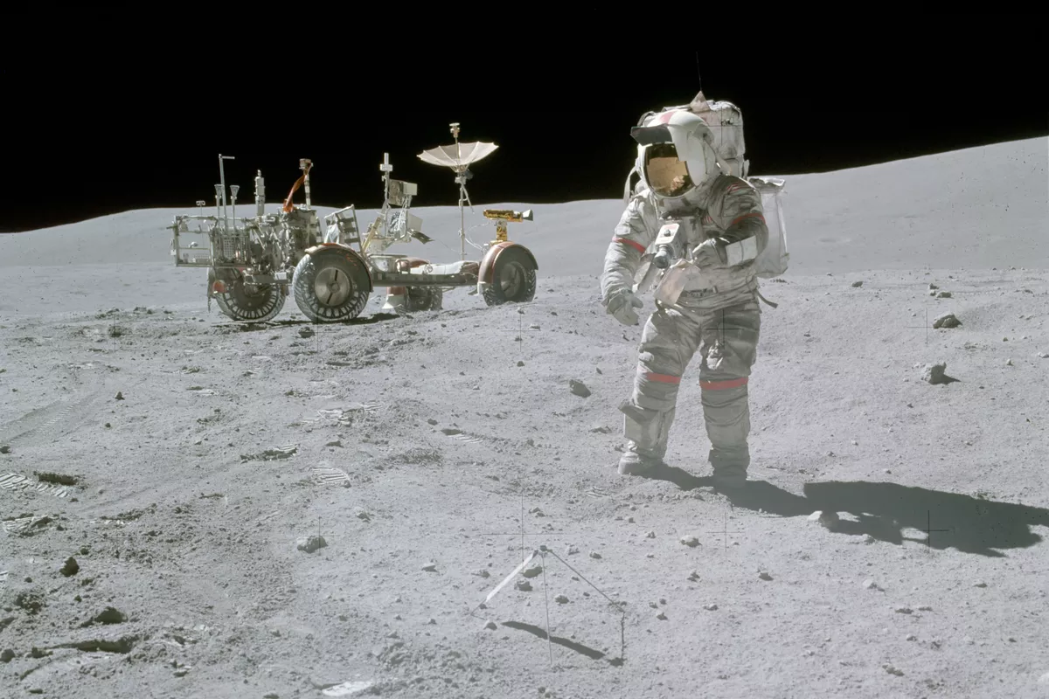 | Research and produce an information leaflet about the Solar System.  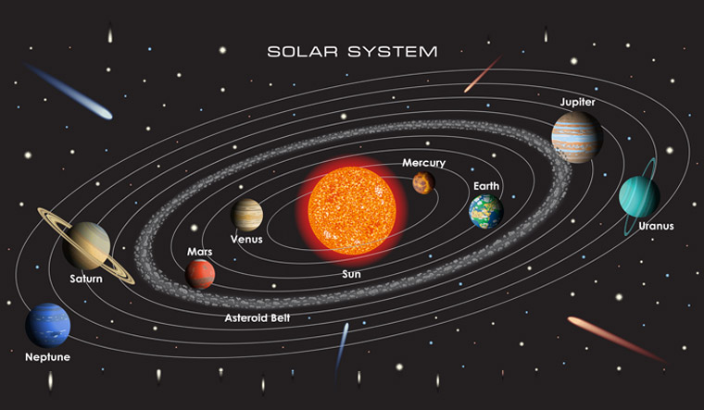 | Create fact cards for each of the Planets.  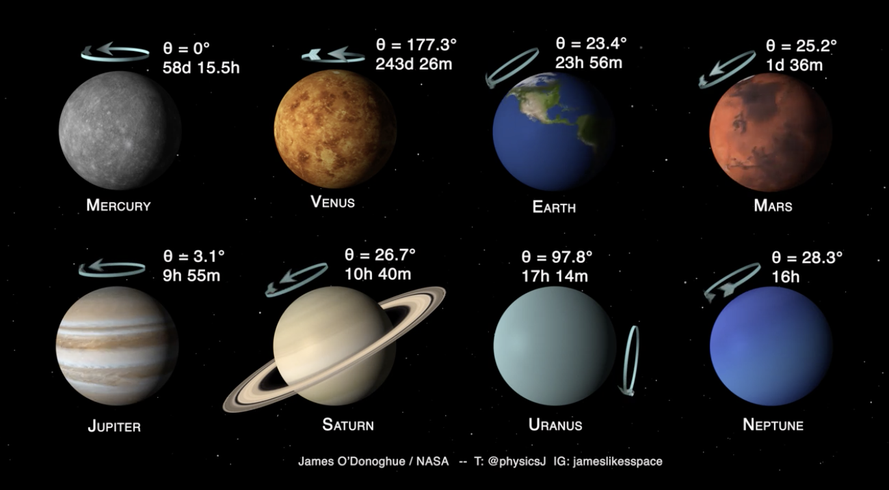
Create a piece of art based on a Constellation.  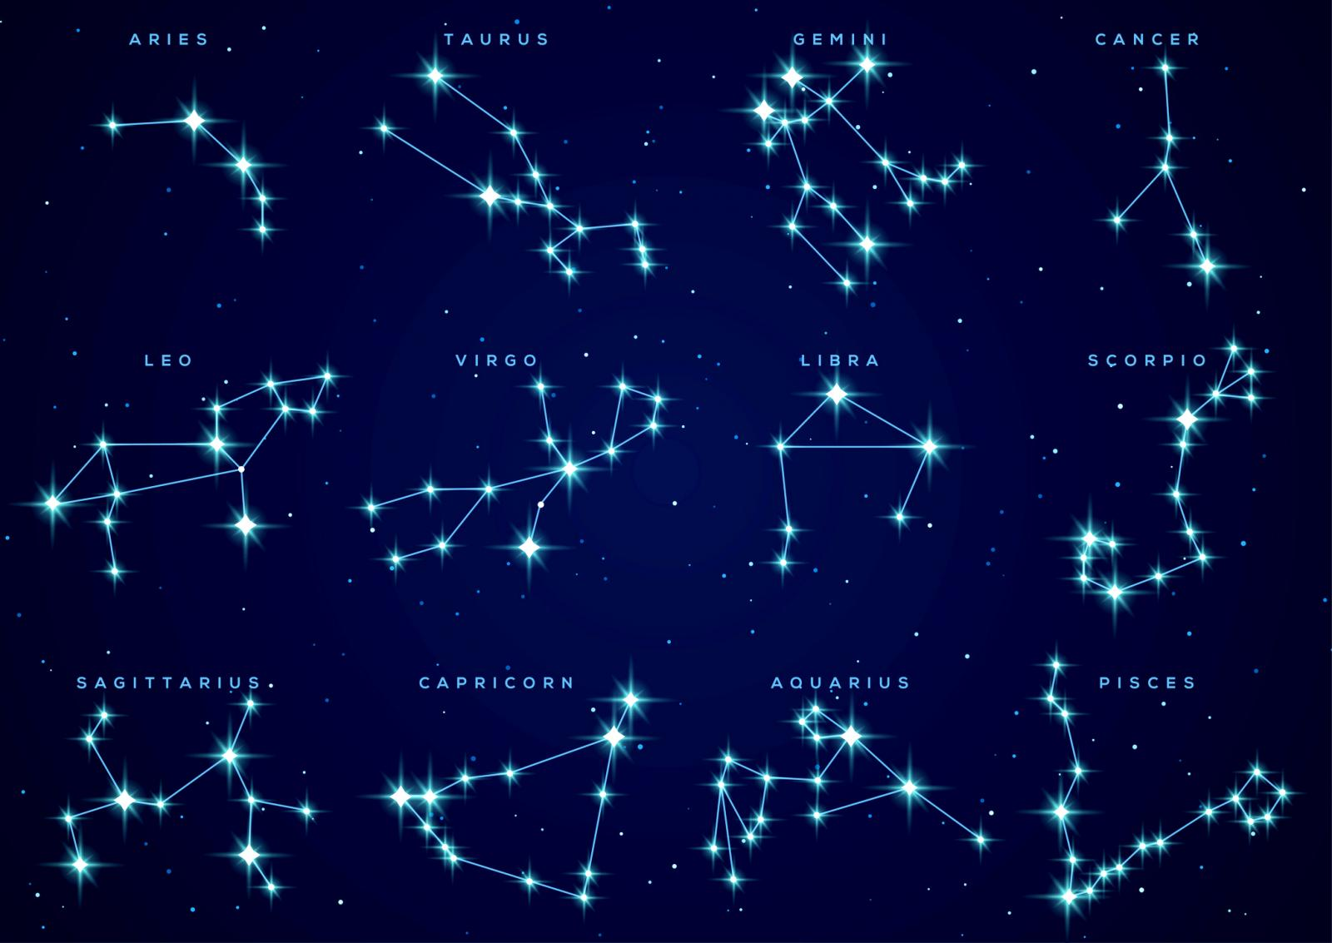 | Write an acrostic poem about Space. | Take photographs of the moon each night to create a moon diary.  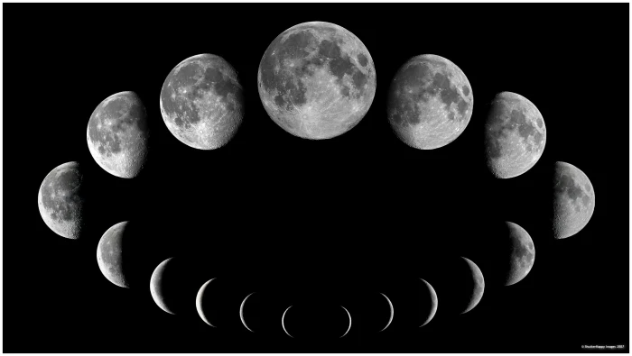 | Write a newspaper report about the first Moon landing.  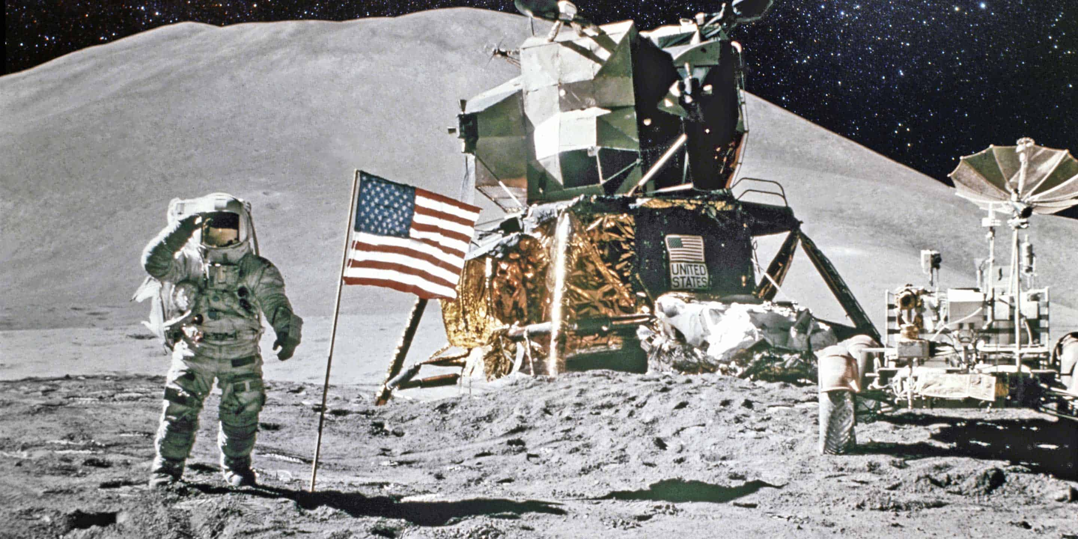
Create a presentation about a key figure linked to space. | Design and make a space themed game.  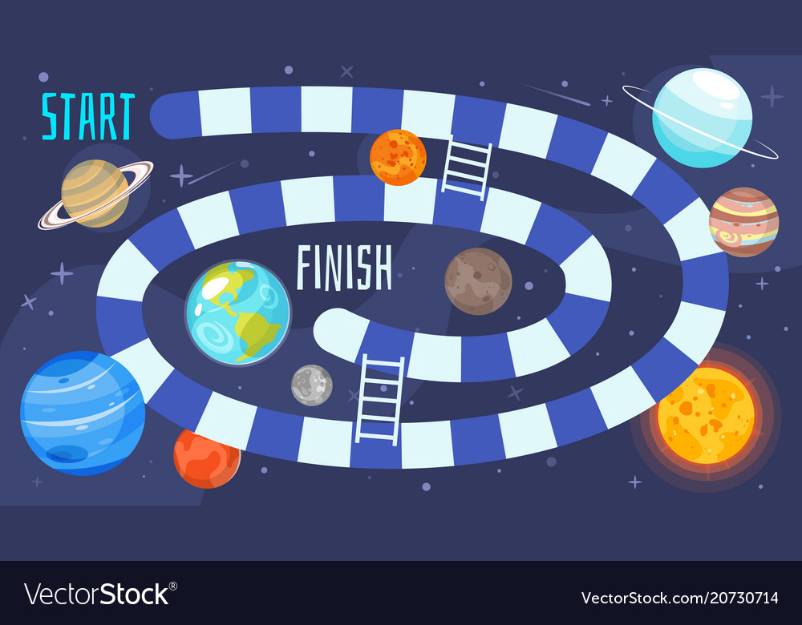 | Make a space helmet.  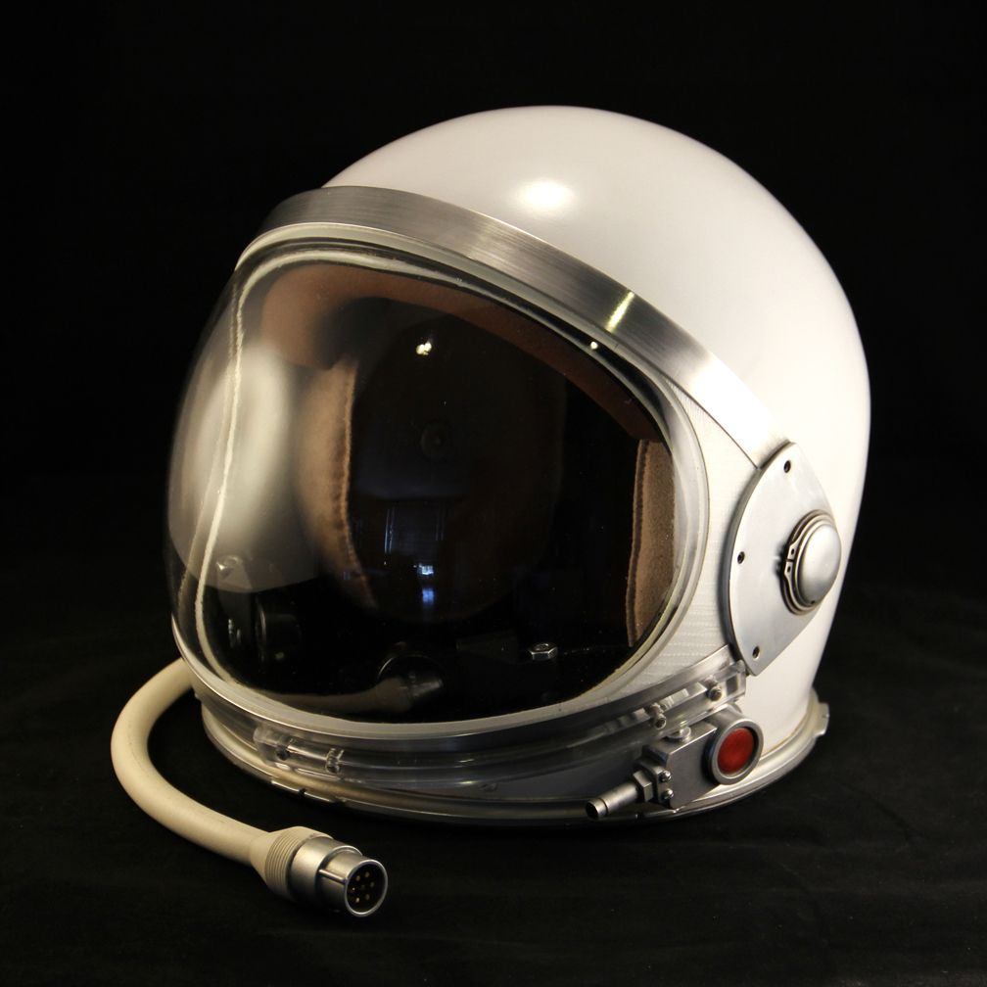 | Make a model of the moon.  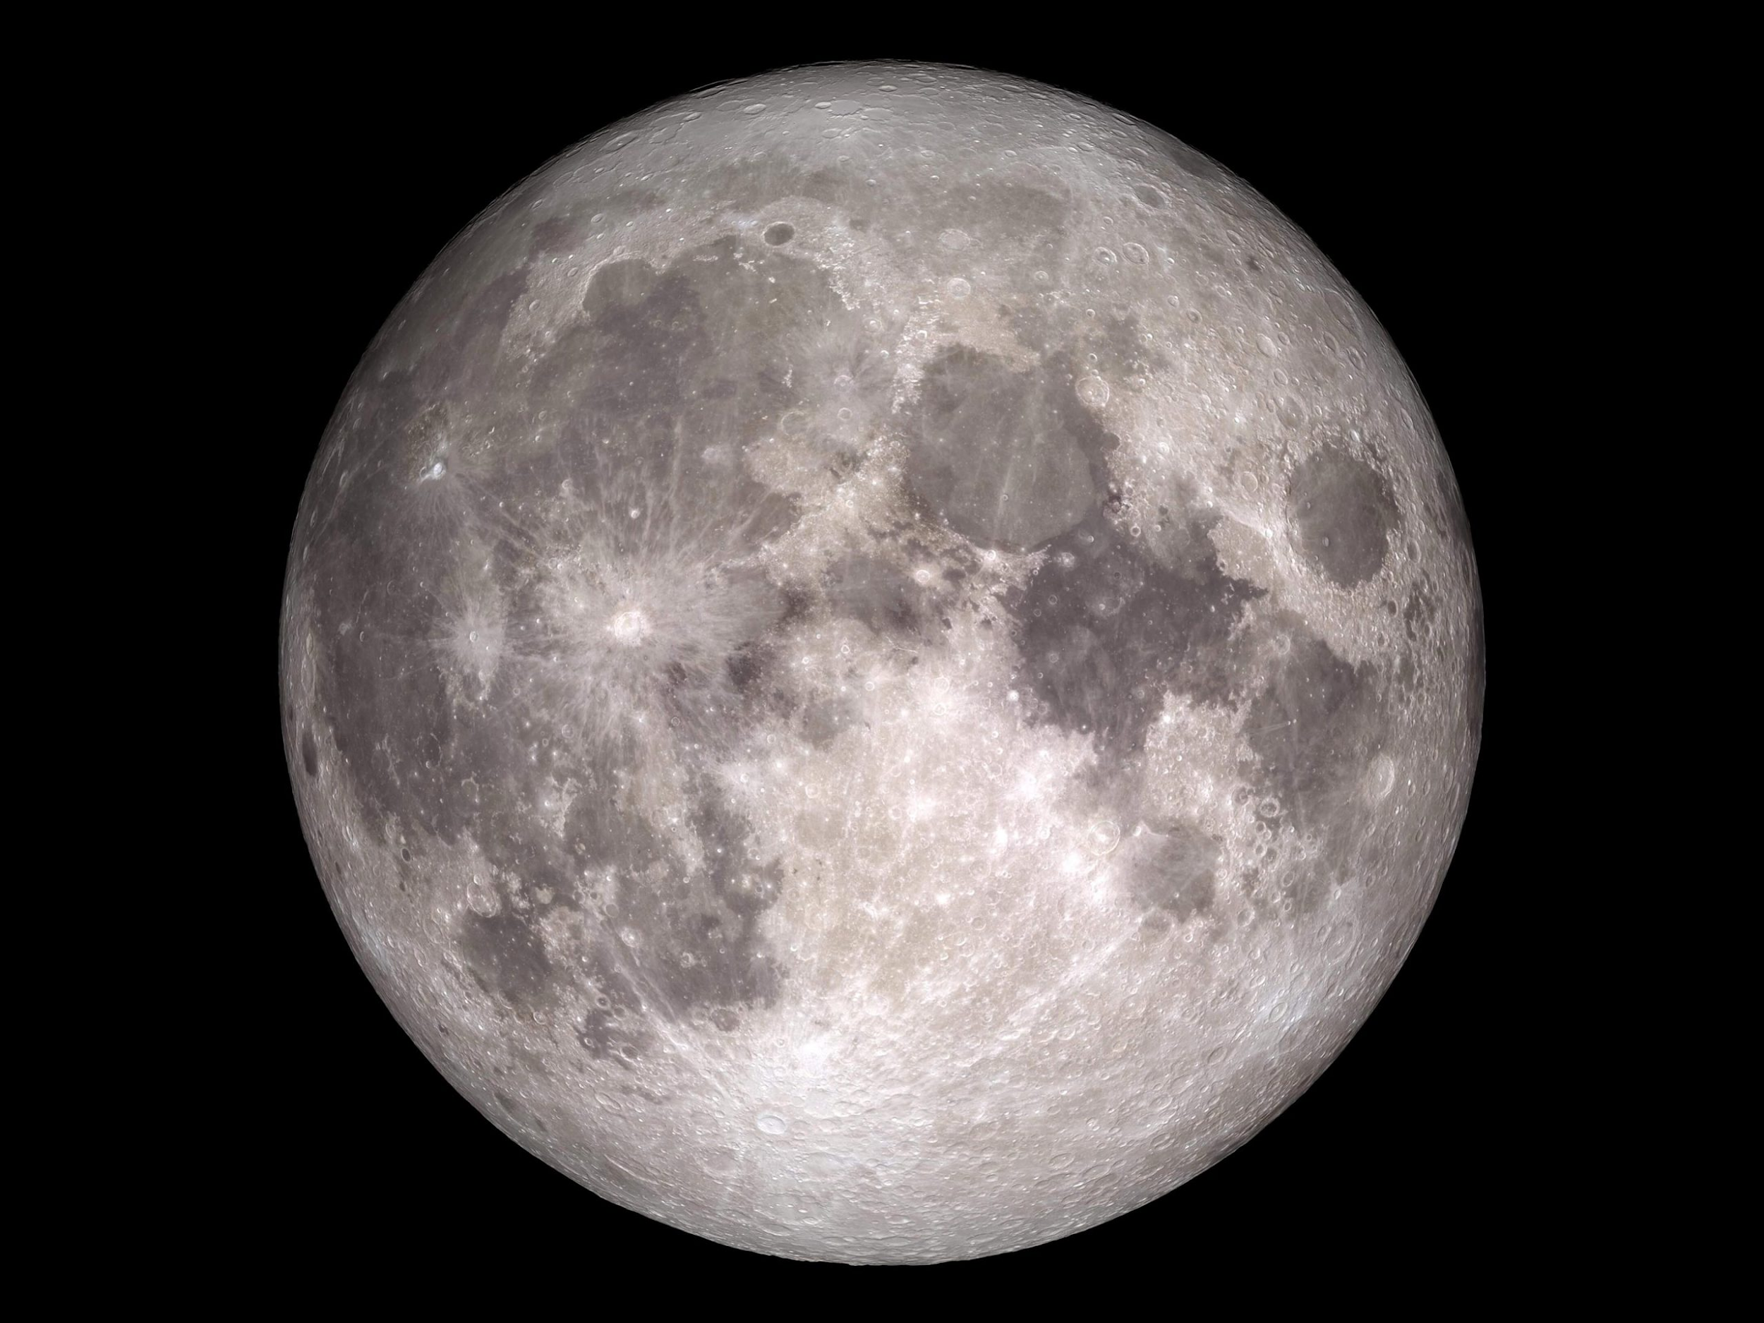
Create a mnemonic for the planets. | Carry out a science experiment testing gravity and produce a table of your results. | Read a story based on Space. | Research and record how astronauts train to go into space.

