Kingfishers Class Term 6 Curriculum Letter 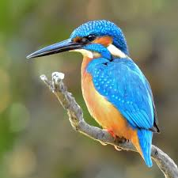

Dear Parents and Carers, Monday 7th June 2021

Welcome back!
I hope that you have all had a nice half term! I can’t believe we are starting our final term of the year! We have a very exciting term ahead!

Topic
Our topic this term is The Olympics. Please make sure that you see our curriculum topic webb on our class page to see what wonderful things we will be doing in each subject this term.

Reading
Please make sure that your children read everyday at home. Every Tuesday Miss Golder will take children to the library to change their book if they need to. Children must read their books very carefully because they will be doing an online test about their book once they have finished it. Your child’s library book must come to school with them everyday and then be taken home every evening, so please make sure they have a book bag to make this routine easier! Finally, your child should have a login for MyOn, so please encourage them to check out some of the brilliant books they have on there at home!

PE
Our PE lessons are on Mondays. For now, children need to come to school wearing their PE kits on this day. Please make sure your child turns up wearing the follow:
- Navy or black jogging bottoms for the winter
- Navy or black shorts
- White t-shirts
- Trainers or plimsolls

Homework
As always, there will be a grid of fun topic related homeworks for your child to complete at home about the Olympics! Additionally, your child will also have spellings to practice each week. These spellings will be posted onto google classroom every Monday and the tests will be every Friday. There will also be English homework given out every other week. There is not a deadline for when this must be returned, but I will give out dojos to those children who make an effort to complete and hand in their homework. Finally, please make sure that your child is making the most of Times Tables Rock Stars to practise their times tables. I have really noticed that those children who regularly go on TTRS at home, are becoming much quicker and confident in their times tables!

If you ever have any questions or concerns please do not hesitate to message me on class dojo. Let’s have a great last summer term! :)

Miss Jessop.

