Invaders Homework!
Pick 3 of these projects to complete and earn a house point for each project. Bring your projects in by Wednesday 6th October.
Design your own shield.  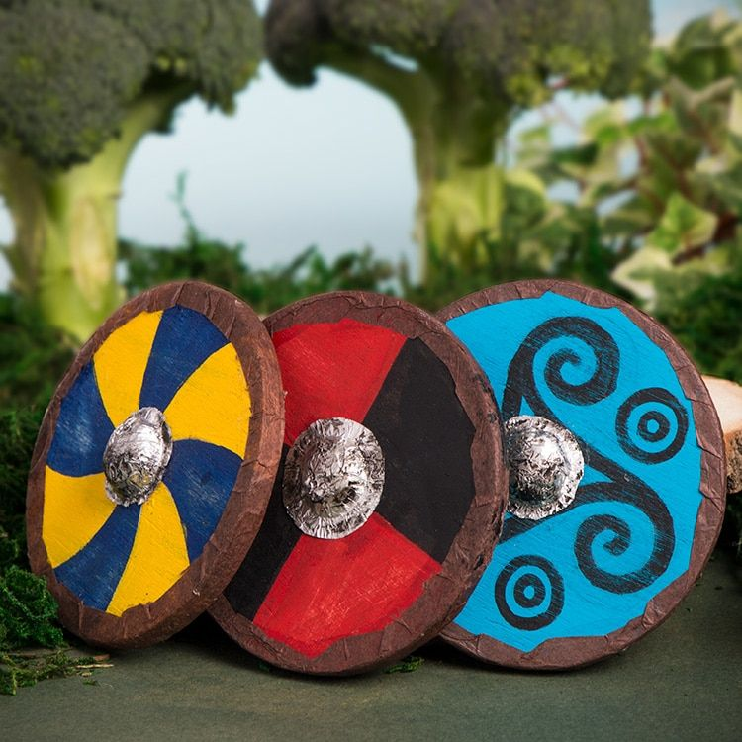 | Research and create a leaflet on how to invade.  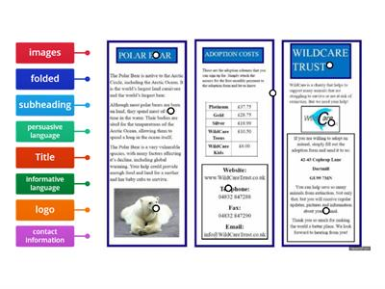 | Write a newspaper report about a British invasion of your choice.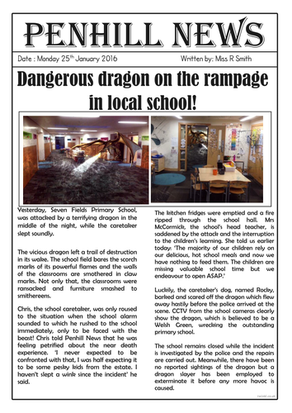 | Draw Julius Caesar.
Design and create your own farm- Animals? Crops?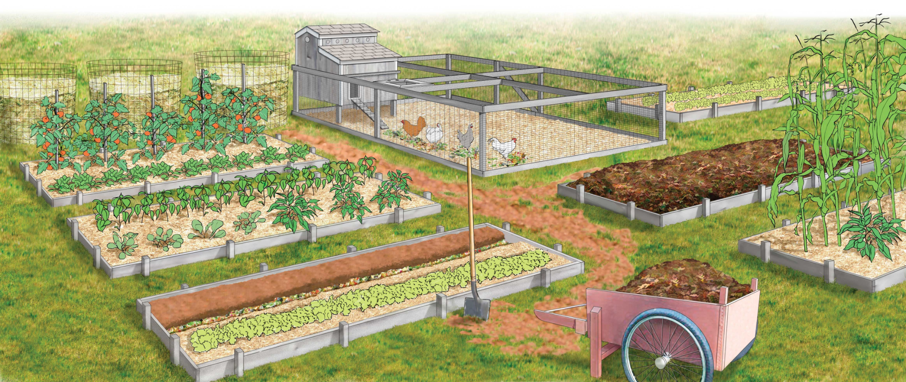 | Create your own armour.  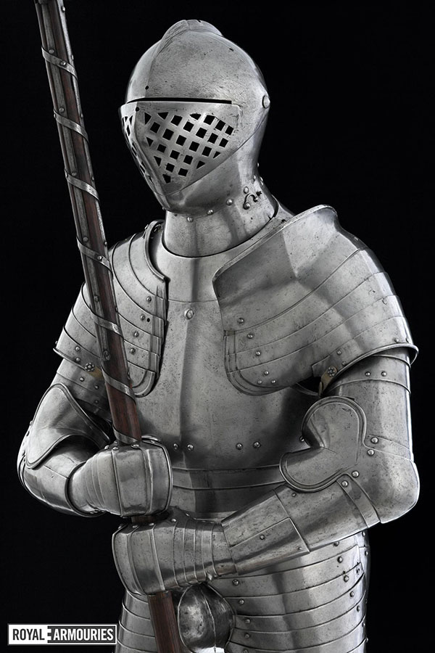 | Design and create your own settlement. 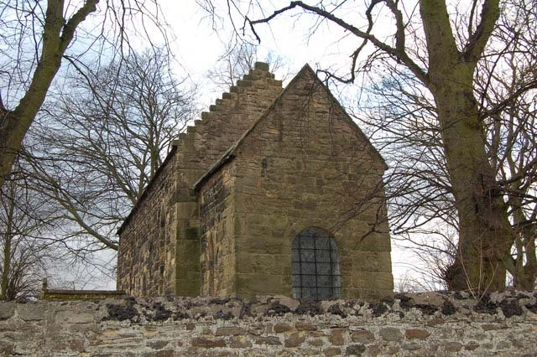 | Research about a British invasion of your choice and create an informative poster. 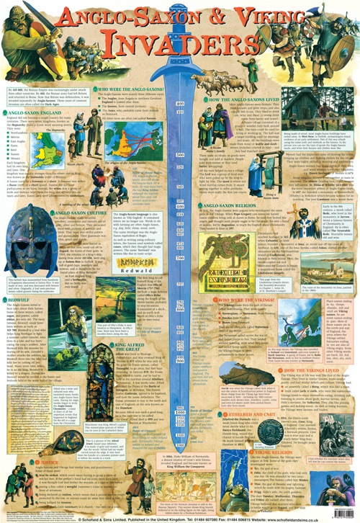
Build a Viking ship.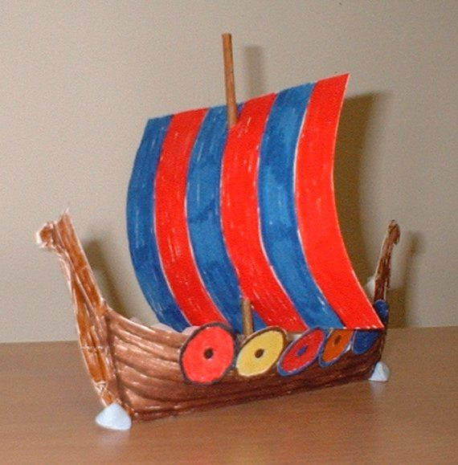 | Create an interactive timeline of British Invasions. | Record yourself performing to this term's song, ‘Livin’ on a Prayer’. | Use a map to plot the invasion routes of different colonies. 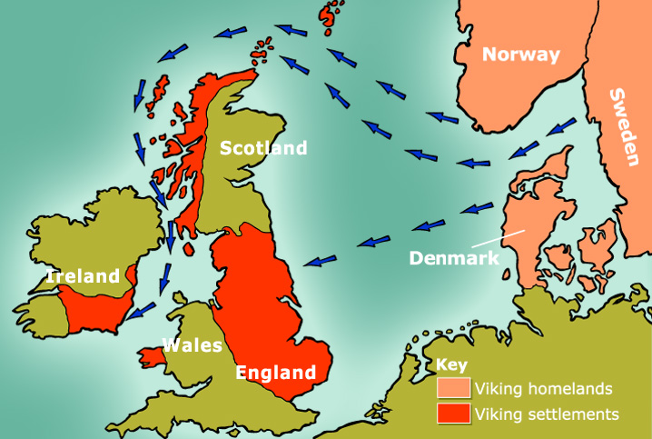
Create a picture using pieces of fruit and vegetables. | Write instructions on how to make your own helmet.  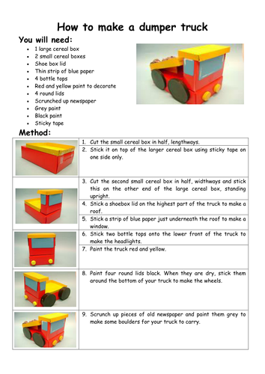 | Use research to find out why people wanted to settle in Britain and write down the reasons.  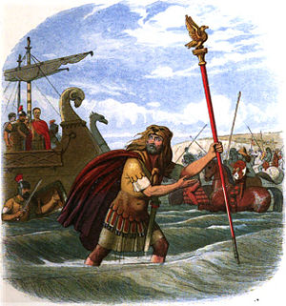 | Research which crops are grown in the UK and how much it costs.

