Fairytale Homework
Make your own house to tempt children in from the forest!  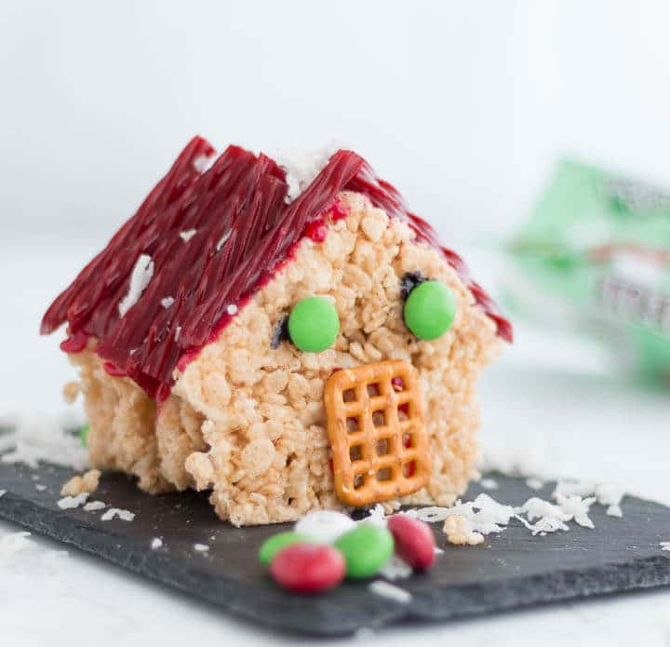  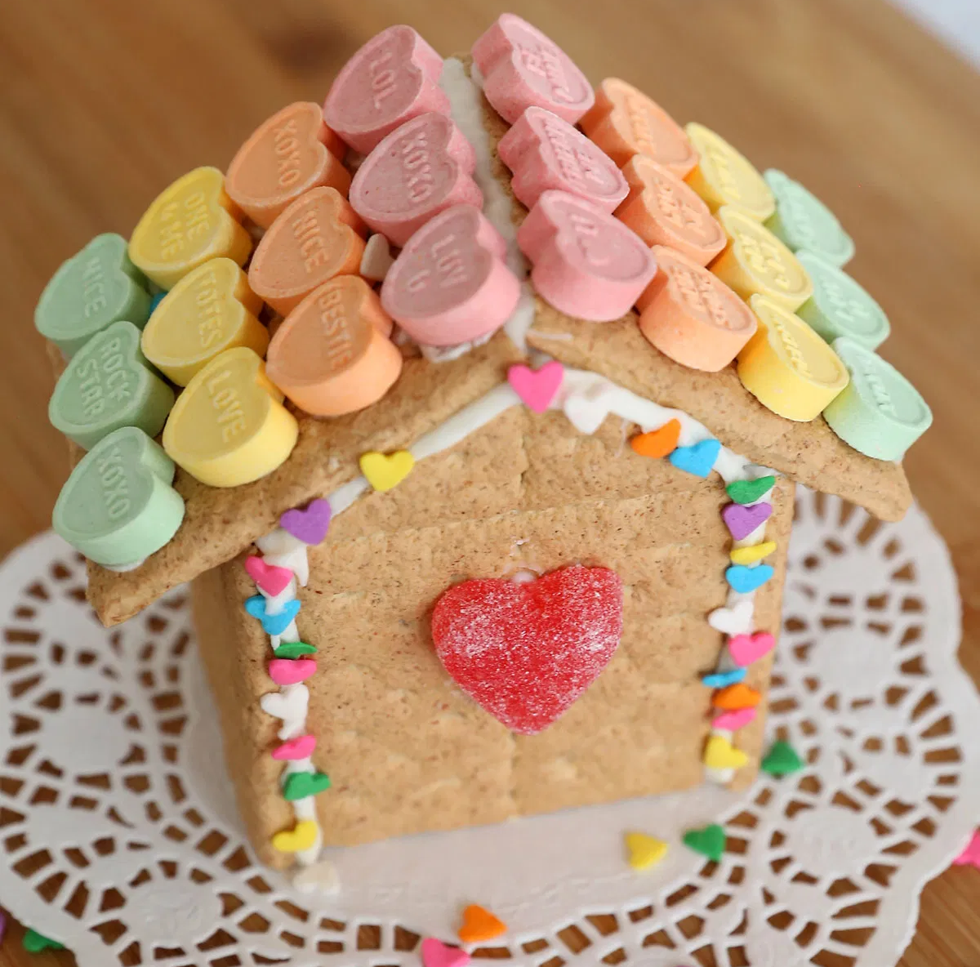 | Make your own puppets and act out the story of Hansel and Gretel.  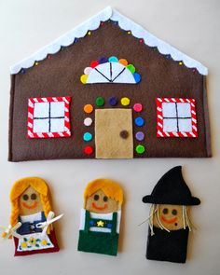 | Read an alternative version of a fairy tale!  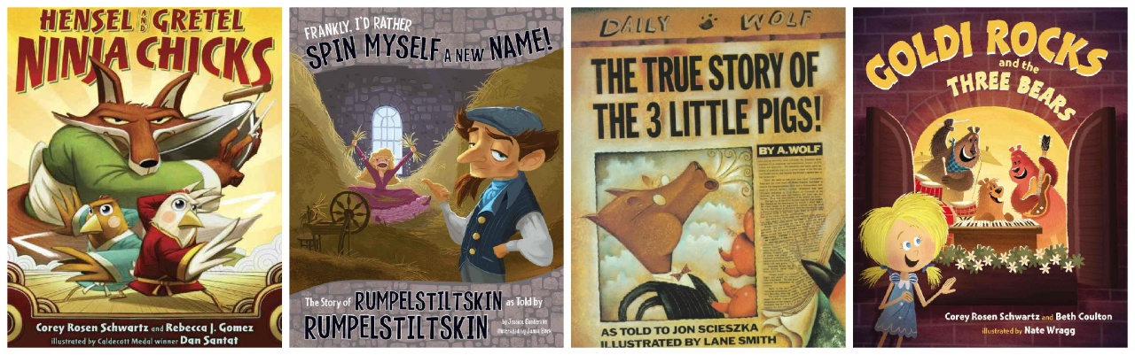 | Build your own castle!  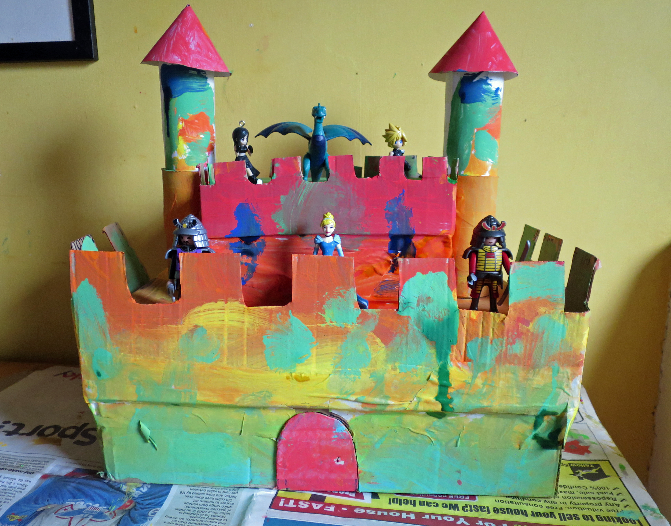
Grow your own giant bean stalk.  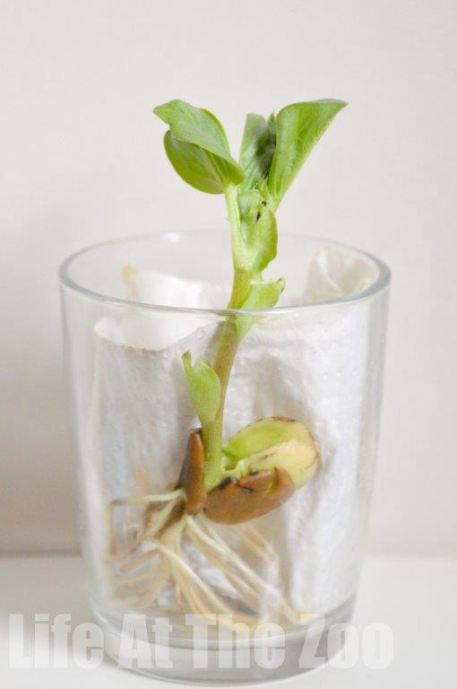  How tall will it grow? | Learn about a King or a Queen from the past. Write down some facts about them. | Use wool (or someone’s hair) and learn how to plait.  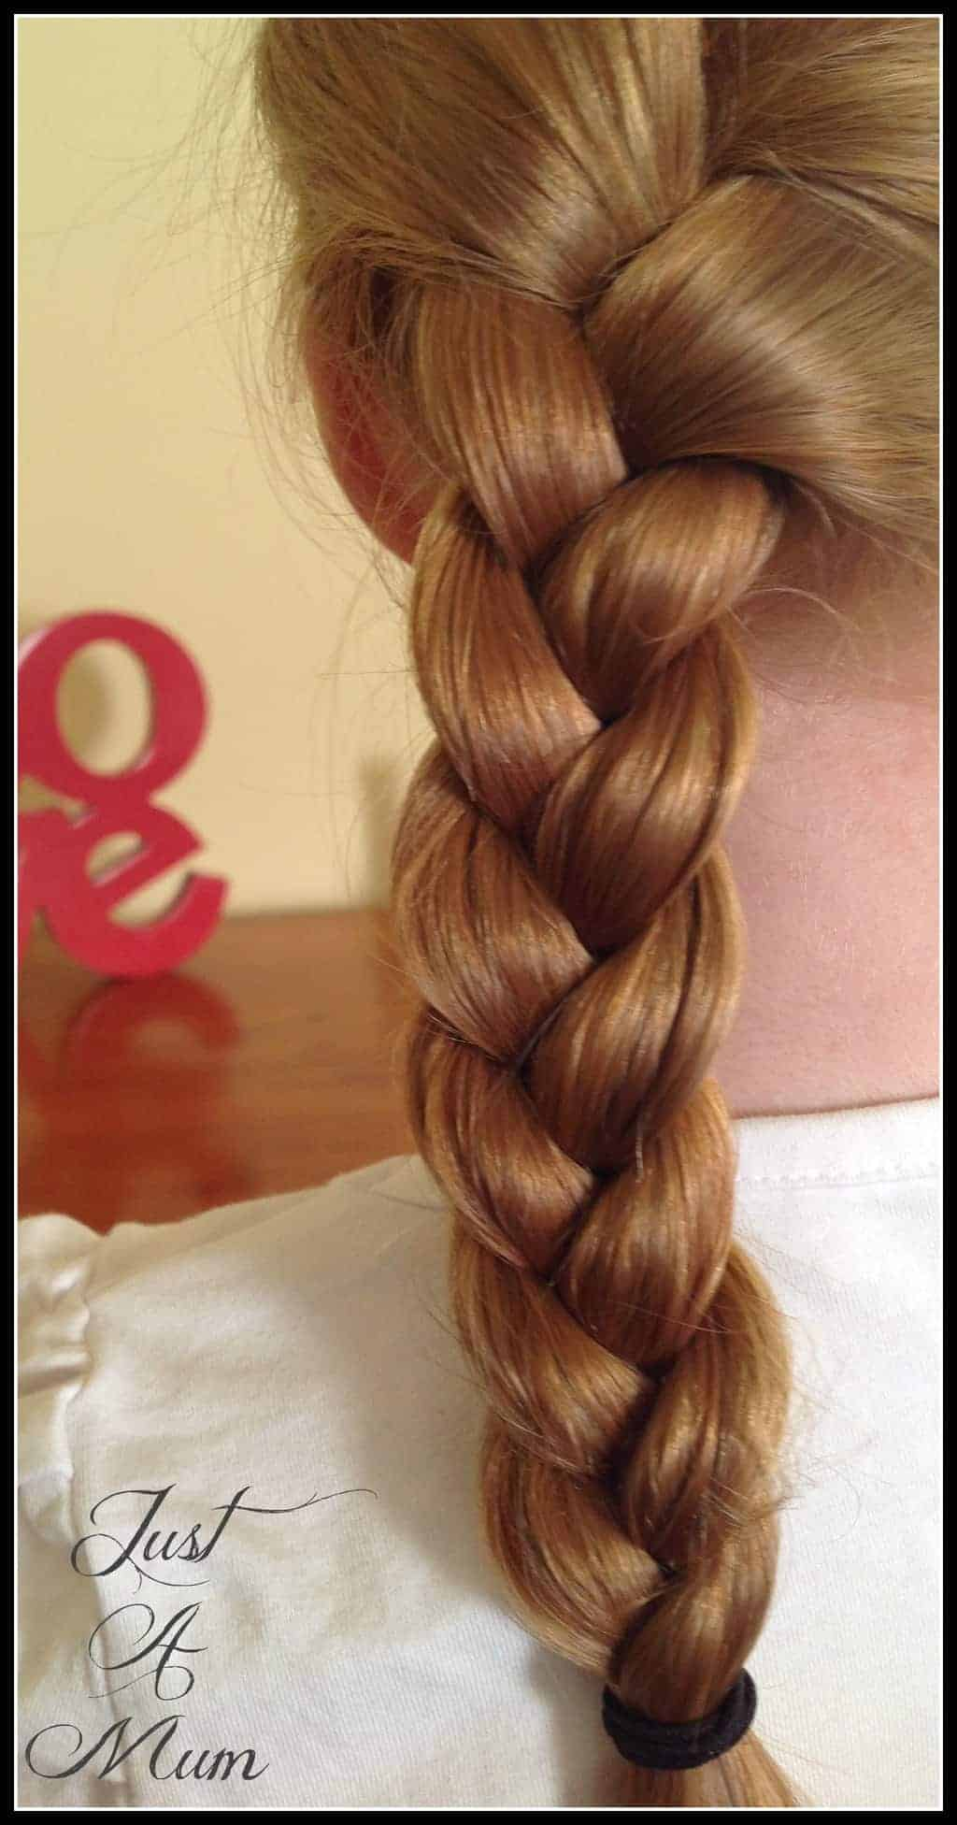 | Draw a map from your house to school to help you if you ever lose your way!  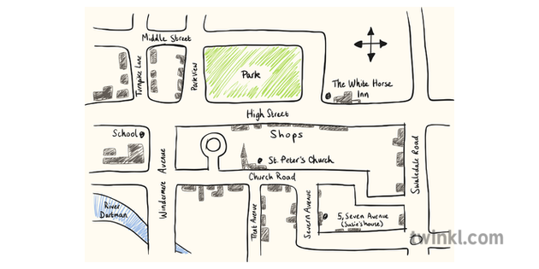
Learn a song from a fairytale film | Make a wanted poster for a character on Hansel and Gretel.  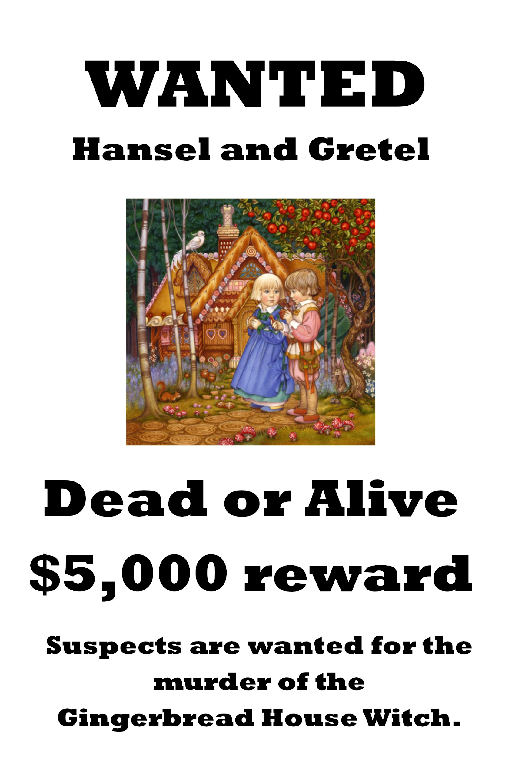 | Look at a fairytale and create a graph about the animals you see in the book  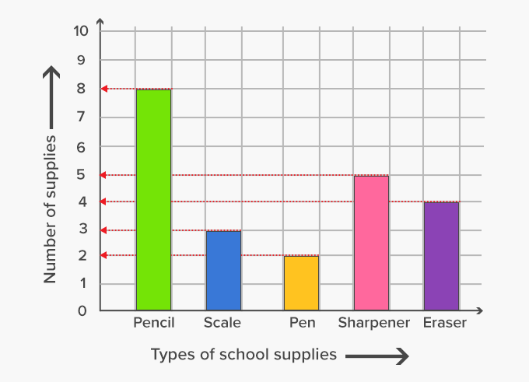 | Write your own fairy tale. . .  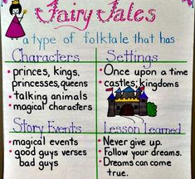
Read another fairytale. Film yourself reading or write a book review about your choice.  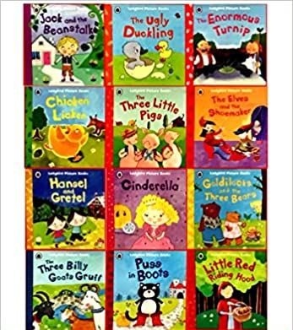 | Do some yoga to Little Red Riding hood  https://www.youtube.com/watch?v=6u5QoqgtT9w | Paint a fairytale garden or character  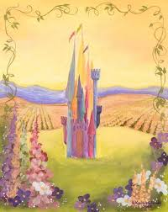 | Make your own Rapunzel tower.  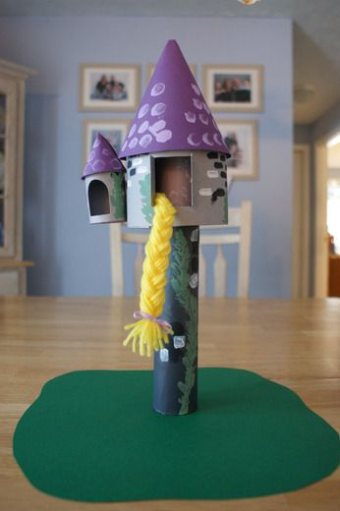
Pick four (or more) Animal project homework tasks and earn 1 Housepoint per completed project.
Please send us pictures on Dojo once a task has been completed! We look forward to seeing your creations!
Mrs Crane, Miss Bickle and Mrs Baker

