**Literacy**

* Letters and sounds ~ phonics phase 1
* Continue to develop phonological awareness.
* Understand print can have different purposes.
* Engage in extended conversations about stories, learning new vocabulary.
* Begin to use some print and letter knowledge in their early writing.
* Begin to write some letters in their name.
* Books to include; Jack & the beanstalk, The pig in the pond and non-fiction.

**Communication & Language**

* Enjoy listening to longer stories.
* Use talk to organise themselves and their play e.g.’Let’s go on a bus… you sit here.’
* Be able to express a point of view and to debate when they disagree with an adult or friend, using words as well as actions.
* Continue to develop their communication skills.

**Personal, Social & emotional development**

* Play with one or more other children, extending and elaborating play ideas.
* Help to find solutions to conflicts and rivalries- suggesting new ideas to solve the issues.
* Talk with others to solve conflicts.
* Begin to understand how others might be feeling.

C:\Users\hwilliams.GHSCHOOL\AppData\Local\Microsoft\Windows\Temporary Internet Files\Content.IE5\FXP5PZHL\MC900368422[1].wmf C:\Users\Hilary\AppData\Local\Microsoft\Windows\INetCache\IE\LKYWVXCE\PngMedium-chicken-and-chicks--16478[1].gif

**Numbers**

* Link numbers and amounts up to 5.
* Talk about and explore 2D and 3D shapes, such as rectangles, triangles, cuboids and spheres. Use informal and mathematical language e.g. ‘corners’, ‘straight’, ‘flat’.
* Select shapes appropriately.
* Combine shapes to make new ones.
* Continue to create patterns.
* Continue to solve real world mathematical problems with numbers to 5.

**Understanding the World**

* Weekly Welly walks in and around our school.
* Talk about what they see, using a wide vocabulary including tadpoles, seed growth, weather.
* Begin to understand the need to respect and care for the natural environment and all living things.
* Plant seeds and care for growing plants.
* Begin to understand life cycles of plants or animals.
* Continue to develop positive attitudes about the differences between people.

**Physical Development**

* Start to take part in some group activities which they make up for themselves, or in teams.
* Collaborate with others to manage large items, such as moving a large plank safely.
* Use a comfortable grip with good control, when holding pens and pencils.
* Continue to eat independently and learn to use a knife and fork.
* Make healthy choices about food and drink.

**Expressive arts and design**

* Explore colour and colour mixing.
* Continue to draw closed shapes and begin to show emotions in their drawings.
* Make imaginative and complex ‘small worlds’ with blocks and construction kits.
* Sing (matching the pitch) and make music.
* Continue to develop their own complex stories.
* Experiment with clay & different media.

**Nursery**

**Term 5**

**Growing!**

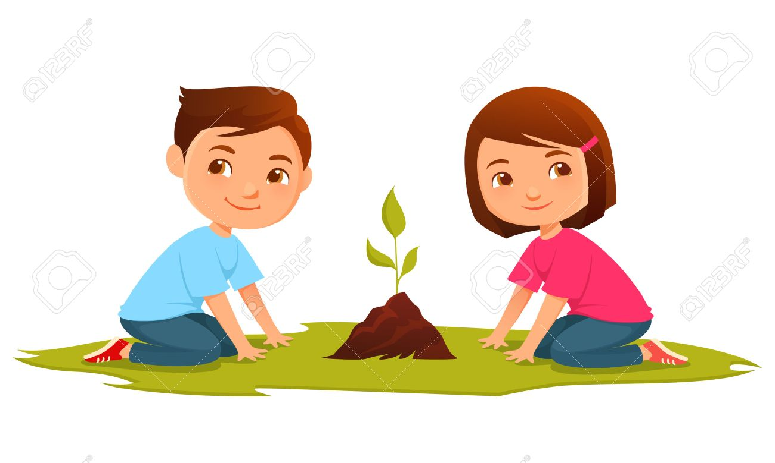

Looking after our world