**Literacy**

* Letters and sounds ~ phonics phase 1
* Continue to develop phonological awareness.
* Sing songs and say rhymes independently.
* Ask questions about a book or story.
* Add marks to their drawings, which they give meaning to e.g. ‘That says Mummy’.
* Continue to mark make and draw freely.
* Books to include; Jack & the beanstalk, The pig in the pond and non-fiction.

**Personal, Social & emotional development**

* Begin to show ‘effortful control’ e.g. waiting for a turn.
* Talk about their feelings in more elaborate ways.
* Notice and ask questions about differences, such as disabilities and hair types.

**Communication & Language**

* Identify familiar objects and properties, when they are described e.g. ‘blue car’, ‘shiny apple.’
* Start to say how they are feeling, using words as well as actions.
* Begin to understand simple questions starting with ‘who’, ‘what’ or ‘where’.
* Continue to develop their communication. skills.

C:\Users\hwilliams.GHSCHOOL\AppData\Local\Microsoft\Windows\Temporary Internet Files\Content.IE5\FXP5PZHL\MC900368422[1].wmf C:\Users\Hilary\AppData\Local\Microsoft\Windows\INetCache\IE\LKYWVXCE\PngMedium-chicken-and-chicks--16478[1].gif

**Expressive arts and design**

* Explore colour and colour mixing.
* Explore paint, using fingers, brushes and other tools.
* Express ideas and feelings through making marks and sometimes give meaning to these marks.
* Enjoy and take part in action songs.
* Use their imagination as they consider what they can do with different materials.
* Experiment with clay, foam & different media.

**Numbers**

* Use counting-like behaviour, such as sounds, pointing and saying numbers in sequence.
* Talk about and explore 2D and 3D shapes.
* Build with a range of resources.
* Continue to notice and create patterns.
* Compare amounts saying ‘lots’, ‘more’ or ‘same’.
* Continue to take part in number rhymes.

**Understanding the World**

* Weekly Welly walks in and around our school.
* Explore and respond to different natural phenomena, including tadpoles, seed growth, weather.
* Begin to understand the need to respect and care for the natural environment and all living things.
* Plant seeds and care for growing plants.
* Notice how people are different.
* Observe (where possible) and talk about seed growth, tadpoles, farm animals, weather.

**Nursery**

**Younger children**

**Term 5**

**Growing!**

**Physical Development**

* Continue to develop manipulation and control.
* Explore different materials and tools.
* Begin to use a comfortable grip when holding pens and pencils.
* Show an increasing desire to be independent when eating, dressing etc.
* Ride a trike or scooter.
* Develop ball skills e.g kick, throw, catch.

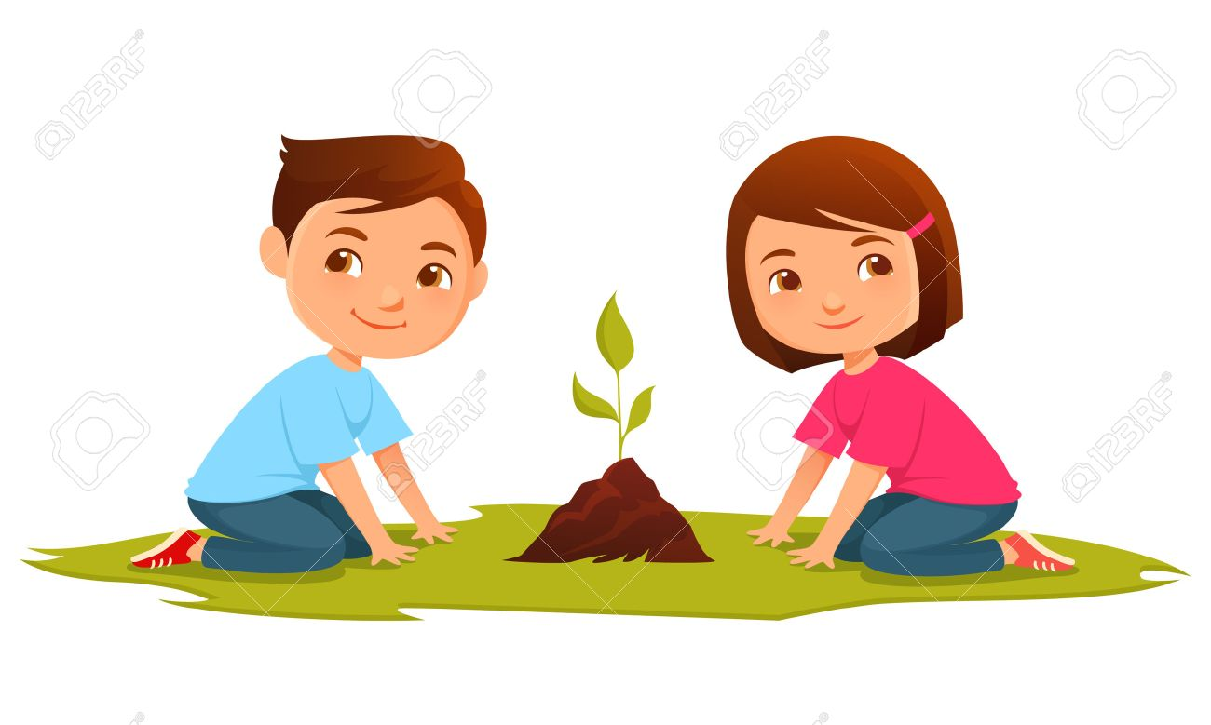

Looking after our world