**Communication and Language**

Develop speaking skills

Show interest in play with sounds, songs and rhymes.

Listen to others one to one or in small groups, when conversation interests them.

Understand ‘who’, ‘what’, ‘where’ in simple questions and ‘under’, ‘on top’, ‘behind’.

Ask questions.

Use a range of tenses (e.g. *play, playing, will play, played*).

Listen to a range of stories including,

The enormous turnip

The little red hen

Lift the flap books e.g. Spot

**Physical Development**

Use the nursery climbing equipment confidently.

Use balls, hoppers, rockers and other items.

Beginning to use three fingers (tripod grip) to hold writing tools

Run skilfully and negotiate space successfully,

Help with clothing, such as coat and painting apron.

Tell adults when he/she is hungry or tired or when they want to rest or play.

Join in with action songs and rhymes.

**Literacy**

Letters and sounds ~ phase 1 phonics.

Fill in the missing word in a known rhyme or story

Look at books independently.

Join in rhyming activities

Mark make using a range of media

Begin to give meaning to marks as they draw and paint.

V

**Understanding the World**

Explore the nursery environment

Investigate our bodies, our senses and our abilities.

Show an interest in the lives of people who are familiar to us.

In pretend play, imitates everyday actions and events from home e.g. feeding the baby

Notice detailed features of objects in their environment.

Talk about some of the things they have see

Make toys work by pressing parts or lifting flaps.

Celebrate Harvest and signs of autumn.

**Term 1**

**Mathematics**

Recite numbers in order to 10.

Begin to make comparisons between quantities

Use some number names accurately in play.

Know that numbers identify how many objects are in a set.

**Shape, space & measures**

Notice simple shapes and patterns in pictures.

Begin to categorise objects according to properties such as shape or size.

Show interest in shapes in the environment.

Use shapes appropriately for tasks.

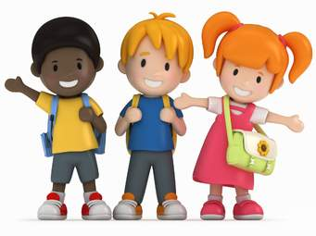****

What will we talk about?

Meeting new friends

My family

Name my body parts e.g. leg, elbow

Using my senses- see, hear, touch, taste, smell.

I can……

**Expressive arts and design**

Mark make (eg paint, chalk, crayons, fingers in foam or paint)

Draw myself

Print with harvest fruit, objects & hands

Sing, join in ring games and use instruments

Begin to make-believe by pretending.

Use various construction materials.

Engage in imaginative role-play based on own first-hand experiences.

**Personal, Social and Emotional Development**

Settling in & meeting new friends.

Show an interest in others’ play and start to join in.

Keep play going by responding to what others are saying or doing.

Show own preferences and interests

Begin to express their own feelings such as sad, happy, cross, scared, worried.

**All about me!**