Extreme Earth Homework
Create an advice leaflet outlining what to do should a volcano erupt.  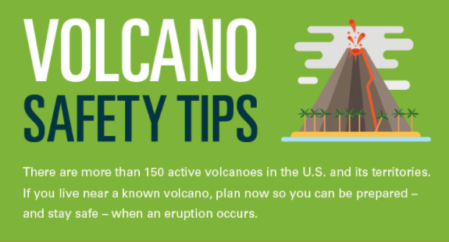 | 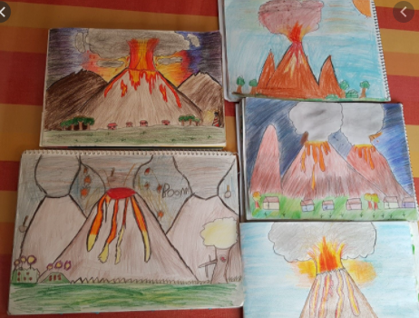  Draw a picture of a volcano scene | Write an acrostic poem using the letters from the word ‘VOLCANO’  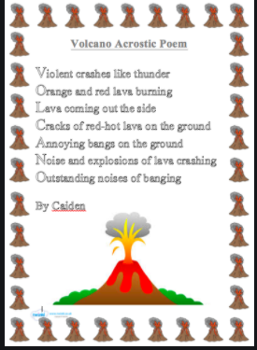 | Fact page about volcanoes or Pompeii  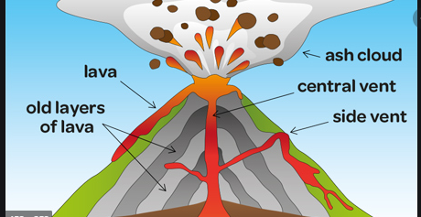
Make a 3D volcano model  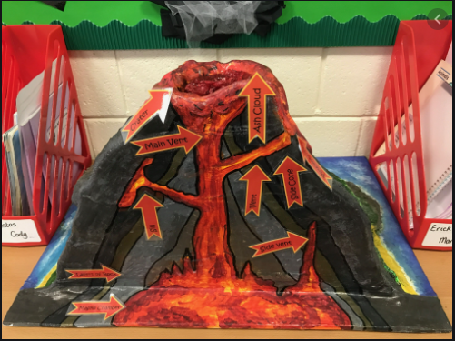 | Write an adventure story set around a volcanic eruption / Pompeii  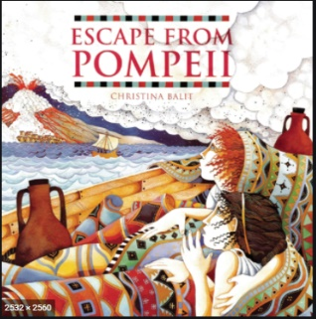 | Research and present findings in your own words about different types of volcanoes  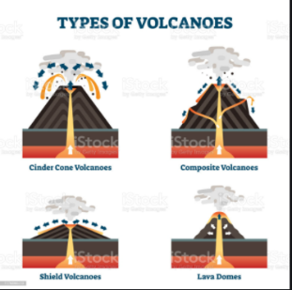 | Create a board game inspired by volcanoes  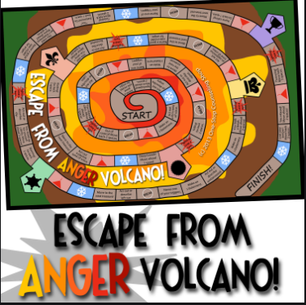
Create a fact file or poster about how Earthquakes happen  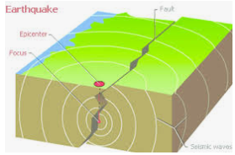 | Create a leaflet about what do in an earthquake.  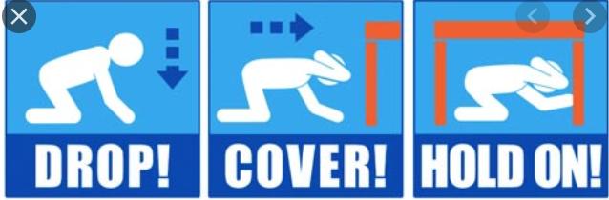 | Write an explanation text about the Richter scale.  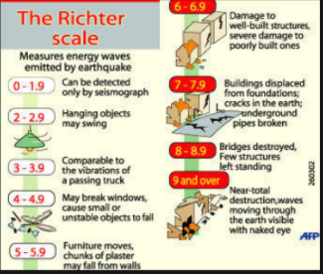 | Create a story about an Earthquake.  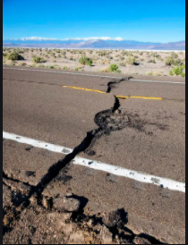
Pick four Extreme Earth project homework tasks and earn house points for each completed project.
Hand in date – Wednesday 10th February. We look forward to seeing your creations!
Miss Roberts and Miss Smith

